
K&M Tire

Ag Specialist Sales Manual
08/24/2023

Table of Contents
Ag Specialist Sales Manual i
Table of Contents ii
1. Introduction & Objectives 6
2. Responsibilities 7
3. Telenotes – CRM 9
4. Weblink 2.0 Best Practices 12
4.1 Enter Username and Password 13
4.1.1.1 Home screen 13
4.1.1.2 Transfer or PR Account 14
4.2 Tire Search 15
4.2.1 Search Options 17
4.2.2 How to Order Product 18
4.2.3 Tube Tab 20
4.3 Wheel Search 21
4.4 Tire Supplies / Equipment Tab 22
4.5 Orders Tab 23
4.5.1 Display Open Orders 24
4.5.2 Order by Part Number 24
4.5.3 Product History 25
4.5.4 Quotes Tab 25
4.6 Resources Tab 26
4.6.1 Tire Guide 27
4.6.2 Education 27
4.6.3 Financials 27
4.6.4 Plus, Fitments 28
4.6.5 Promotional Items 28
4.6.6 Warranty Info 29
4.7 My Account Tab 30
4.7.1 Make Payment 30
4.7.2 Invoices 31
4.7.3 Statement 32
4.7.4 Change Password 32
4.7.5 Feedback 33
4.7.6 Help 33
4.7.7 Messages 34
4.7.8 Settings 34
4.7.8.1 User Settings 35
4.7.8.2 Markups 35
4.7.8.3 Quotes 35
5. Intranet Best Practices 38
Ranking report, Weblink Login report, Vendor Programs report, Customer Information, Closed Order Search, Open Order Search, Sales Analysis, Inventory Control 38
6. Dashboard & MaddenCo Best Practices 39
6.1 Dashboard 39
6.2 MaddenCo 40
7. Sales Call Best Practices 41
7.1 Established Program Dealer 41
7.2 Established Dealer / Program Prospect 41
7.3 Current Prospect 42
7.3.1 New Prospects – First Call 43
7.4 Commercial and/or Ag Focused 44
7.5 Forms 45
7.5.1 Credit Application 45
7.5.2 Common Ownership 47
7.5.3 Dealer Request 48
7.5.4 Release of Liability 48
7.5.5 Price Level Change Request 48
7.6 Dealer Programs 49
7.6.1 Goodyear G3X 49
7.6.2 Goodyear Tire & Service Network 49
7.6.3 Bridgestone BARNN 50
7.6.4 Yokohama Advantage 50
7.6.5 Cooper Medallion 50
7.6.6 Mastercraft Century 50
7.6.7 Kumho Premium Fuel 50
7.6.8 Hankook ONE 50
7.6.9 Falken Fanatic 50
7.6.10 Mickey Thompson MTMA 50
7.6.11 Nexen Next Level 50
7.6.12 BKT Growing Together 50
7.6.13 Trelleborg Associate Program 50
7.6.14 Goodyear G3X Commercial 51
7.6.15 Hankook School Bus/Government 51
7.6.16 Yokohama Commercial Advantage 51
7.6.17 Cooper Pinnacle TBR 51
7.7 K&M Specific Program Request 51
7.8 Tool Utilization 51
7.8.1 Laptop 51
7.8.1.1 Regulations 51
7.8.2 Cell Phone 52
7.8.2.1 Regulations 52
7.8.3 Expenses 52
7.8.3.1 What is covered? 53
7.8.3.2 Concur – Expense Report Submission 55
8. Video Library 59
8.1 How to Videos 59
9. Online Vendor Training 60

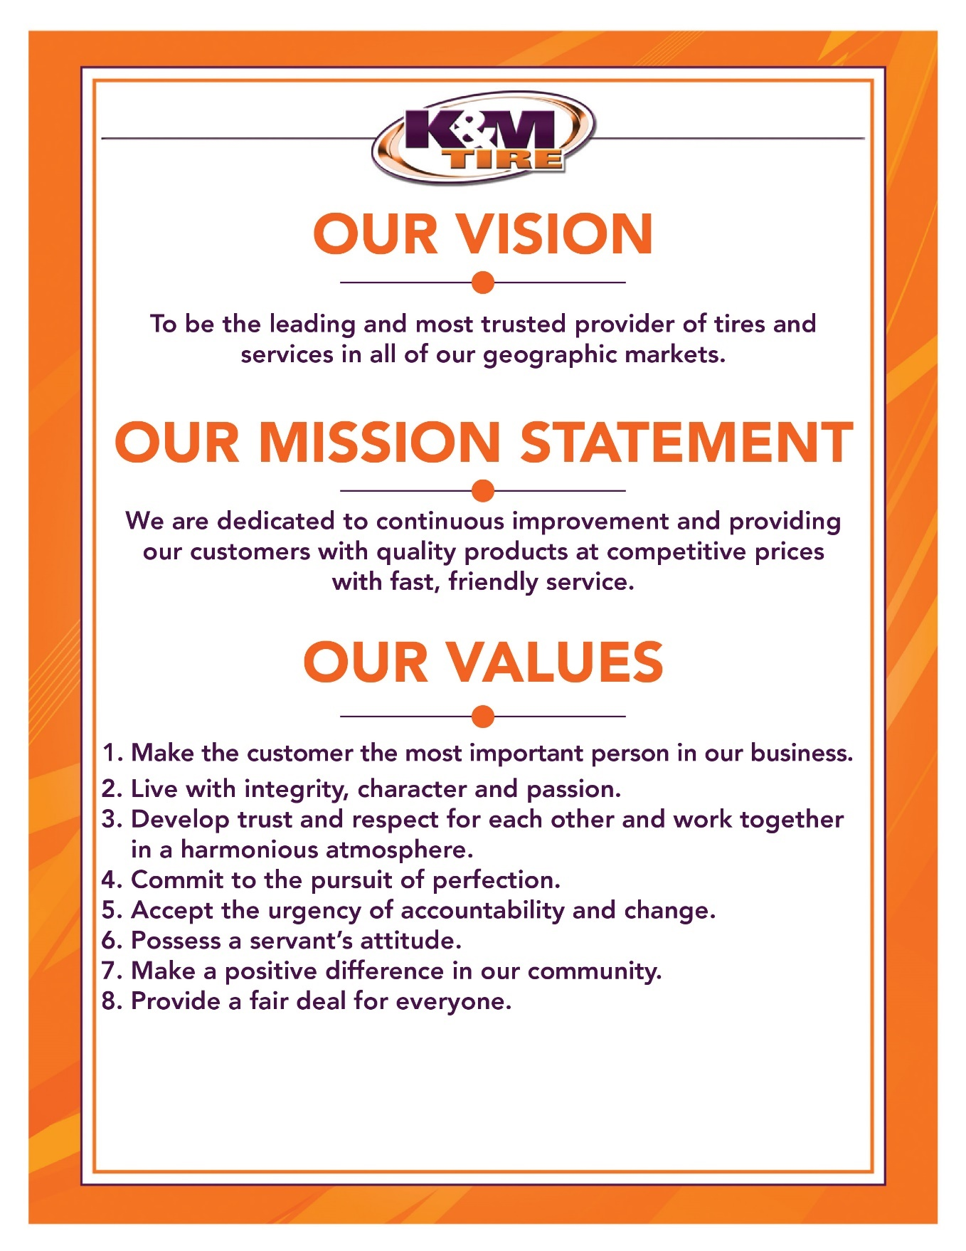

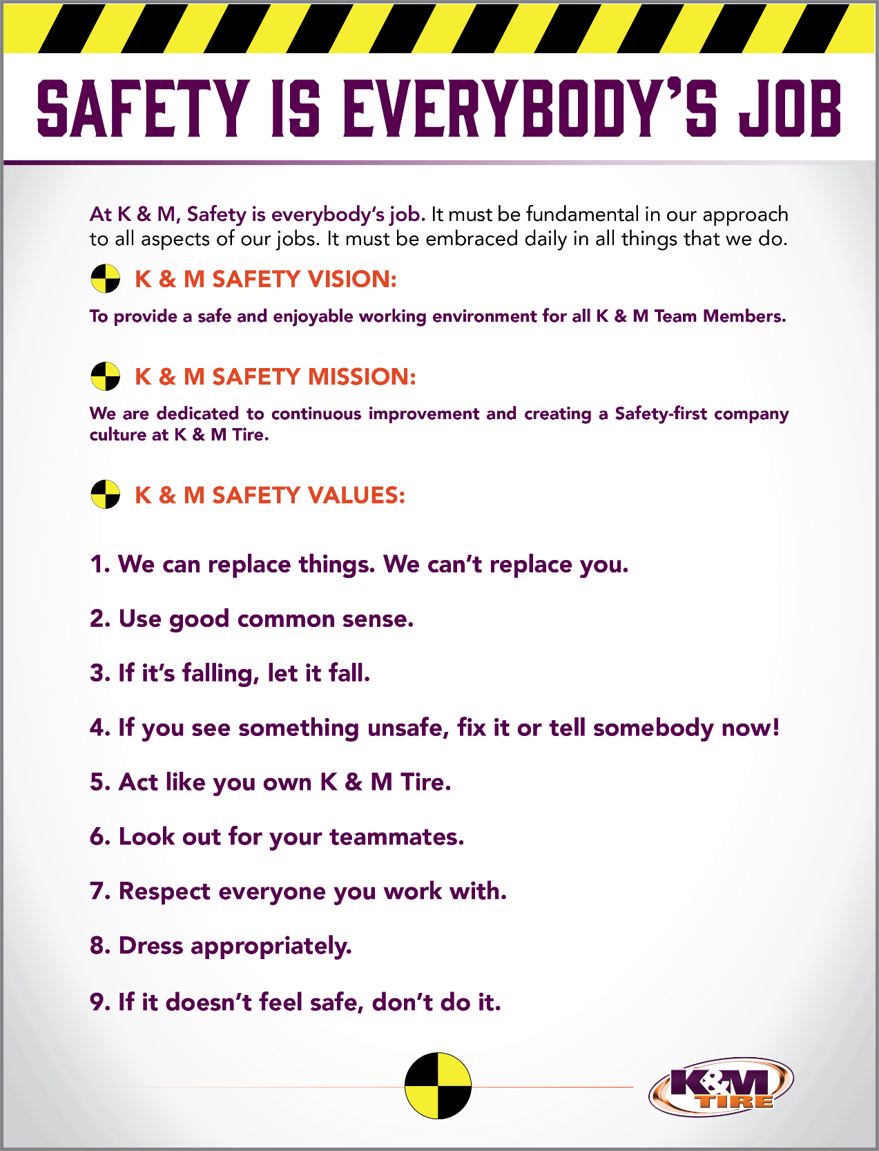

Introduction & Objectives
Welcome to your new role as an AG and OTR sales specialist, a crucial position within K&M, where we strive to become the leading and most trusted partner for our valued customers in all aspects of their business. Your area of responsibility is limited but highly significant.
As part of the team, your primary focus will be on delivering value through technical support, product demonstrations, and in-field assistance. Our customers will rely on you to address their daily challenges in farming and other end-user domains. Given the ever-evolving landscape of equipment and tires, it will be essential for you to maintain a robust knowledge base encompassing new tire sizes, fitments, and common issues faced by farmers. By thoroughly understanding the technical aspects of the Ag market, you will play a pivotal role in providing effective solutions to help our customers grow their businesses.
The goals and objectives outlined in your role are closely aligned with the expectations for the outside sales position. For further details, please refer to the relevant sections in the outside sales SOP.
We believe that your expertise and dedication will make a significant impact on our customers and contribute to the overall success of K&M. We're excited to have you on board and look forward to your valuable contributions to our team!

Objectives
As an AG/OTR Sales Specialist, your primary role will involve driving sales growth within a specific segment of the K&M product offerings. The team will collectively work towards achieving the following goals:
- Increase Sales: Your main responsibility will be to boost sales for classes 8 through 13. We have set an ambitious annual growth target of 20% year over year.
- Acquire New Program Dealers: One crucial aspect of your role will be to secure new program dealers by identifying and capitalizing on opportunities. Section 7.6 of the outside sales SOP outlines the three Ag tire programs that approved dealers can opt for.
By focusing on these objectives, you will play a key role in driving the success of our agricultural sales team. Your dedication and expertise will contribute significantly to achieving our growth targets and expanding our dealer network.

Responsibilities

As an AG/OTR Sales Specialist, your key responsibilities are outlined below. These duties are directly tied to the measurable goals of our team, and in addition to similar duties as the outside sales role, you will have specific tasks that contribute to achieving your sales targets.

Develop and Manage a Territory and Key Accounts:
Unlike the outside sales role, you will be responsible for managing a territory that spans multiple states. A crucial task within the first 90 days is to establish a list of key accounts. While Ag products will be a primary focus, there is room to explore other opportunities beyond these products. To identify potential key accounts, you can utilize dealer locators such as Michelin and Firestone programs, which validate dealers capable of providing on-farm service calls.

Gather Market Intelligence:
As an Ag Specialist, gathering market intelligence is a significant aspect of your role. Understanding competitive pricing is essential to secure business, as some competitors may offer the same brands at lower prices. It will be your responsibility to assess whether price adjustments are necessary to attract such business. Additionally, you may encounter competition from other brands not stocked in our inventory, requiring you to showcase the value of comparable products we offer through your expertise.
Understanding customer needs is vital, considering the evolving demands in the ag industry. Tires are expected to perform faster and carry heavier loads. Working closely with customers to identify their specific needs, preferred brands, and equipment requirements will provide crucial information for your manager to make necessary stocking level adjustments.

Assist Customers with Technical Issues:
Supporting customers with technical issues is an essential part of your role, as it adds value and fosters customer loyalty. Your expertise will be instrumental in evaluating tires that may have failed due to manufacturing defects or misuse. Assisting customers with warranty claims will be beneficial, as you can take this responsibility off their plate and ensure accurate information is gathered. In some cases, involving the manufacturer’s representative may be necessary to ensure a smooth warranty process.
Additionally, you will serve as a resource for customers facing technical problems with their tractor tires. Collaborating with a manufacturer representative to diagnose issues and find suitable solutions will be a regular part of your responsibilities. Successfully resolving these issues will leave the customer satisfied and maintain a positive outlook for the brand, even if they initially experienced a problem.

Train and Educate Customers on New Products:
Staying up to date with new products and changes to existing tires is another critical aspect of your role. As new products are introduced by manufacturers, you will be responsible for keeping customers informed about their features and benefits in detail, particularly if they enhance traction, stability, or overall performance. Similarly, as improvements are made to existing products throughout the year, it will be vital to explain these changes to customers. This helps them understand the updates and ensures a smooth transition when replacing older items in inventory. This proactive approach can prevent confusion and maintain sales that might otherwise go to competitors.

As an AG/OTR Sales Specialist, your role is diverse, involving territory management, market intelligence gathering, technical support for customers, and product education. By excelling in these areas, you will contribute significantly to our team's success and customer satisfaction.

Telenotes – CRM
Telenotes is designed to be your very own virtual assistant. Using this tool will allow you to set important reminders, quickly find account details, prospect for other dealers within a certain city, quickly communicate with your manager and others throughout the company, and much more. A couple of examples of this would be: 1) Setting a reminder of a customer’s birthday – you will receive a reminder email that morning to call the customer and wish them a Happy Birthday! Personal touches like this are remembered far greater than a deal on a set of tires. 2) Searching for account information quickly – you can search for key words within a date range to find any note that has those key words entered in your search. You will also be able to quickly share a note with your manager or others within the company by simply mentioning it during your recording. Leaving a note directly after you leave a customer ensures crucial information is shared without items being forgotten or left out.

Basics of Leaving a Telenotes:
There may be times when you cannot access the Telenotes app due to lack of signal and will have to record your information via phone call. In these instances, you will need to call 800-418-3536 and type in your Telenotes pin to record the note to your account.
When leaving a Telenote via phone call, there are a few key pieces of information that need to be shared at the beginning of each call to ensure the information is recorded to the correct account.
- Company name (making mention of whether it is new or existing in Telenotes)
- Company Information: Address, account number with K&M, etc.
- Contacts: Who you spoke to and their title with the company.
- Call Type: There are multiple types of calls that you can list depending on the nature of your call.
  - New Prospect, New Prospect Car Dealer, New Prospect AG/Comm, Car Dealer, Maintenance, Phone Call, Target Account, & Weblink Setup
Once all the key information is shared for the account, you can begin your call notes by saying the word “Narrative.” This will give the person recording the Telenote the sign that they should start writing all the information in the note itself.

Useful information to share:
When leaving Telenotes, it is important to remember that this is your personal assistant for all things related to a customer. While everyone will have their own style of note dictation, listed below are a few key pieces of information to share.
- Programs currently enrolled in.
- Preferred brands or brands on display in their showroom.
- Business mix – This could be the percentage of PLT, Truck, and AG tire work they are doing.
- Wholesale competitors they are currently buying from.
- Opportunities for growth – Brands or programs to offer that the customer showed interest in.
Follow-up Tasks – You can create a follow up task for a future time and date. To do this, you simply dictate in your message to set a reminder for the date and time specified along with the subject you want to follow up on. A reminder will be sent to your email on the date that you requested.
Emailing Call Notes – You can email your Telenote to a fellow employee or manager as well. At the end of a call note, simply request the email to be sent to a specific employee or manager and it will be forwarded. If the note needs to be sent to someone outside of the company, you will need to dictate the complete email address.

Telenotes App:
The Telenotes app on your phone will be a great mobile source for recalling previous notes or entering the latest information for an account.
Leaving a Telenote in the app is a fairly simple process.
- Find the customer by searching under the companies’ field.
- Click the Plus (+) logo and select new note.
- When ready press record and dictate your entire note. You will not have to mention the company name or account information since it is already selected in the app.
- Dictate all information that you discussed and end the recording.
- You will then click the upload button, and everything will be sent to be transcribed!
Recalling a note in the app:
You can recall all Telenotes left for an account by doing the following:
- Click the three dashes at the top left corner.
- Select “Companies”
- Click the search bar and type the customer's name that you are looking for.
- Once you select the account you want to view, you can scroll through all past Telenotes as well as view the contacts and other company information.

Telenotes in Browser:
The browser version of Telenotes is useful for updating important company information that you may not have mentioned in past calls. https://telenotes.com
Finding a customer:
You can search for a specific customer by clicking the “Companies” bar along the top of the screen. On the next page, type the customer's name and click “Get Companies”. A drop-down box will be populated below with a list of customers to choose from. Once you select the customer you are looking for, click the “load company” button to show all information and prior Telenotes.
Editing Company Information:
Once you find a customer profile, you can edit/add contacts, company info, or special notes by selecting the proper field under company info. Once you have completed any changes that were made, click the update button next to “mailing address info” to complete changes.

Searching call notes:
Call notes for a specific rep or time period can be found by clicking the “Call Notes” link along the top bar. Once there, you can specify the date range, call type and salesperson you want to view.
You can also search for key words mentioned within a Telenote to see who might be talking about a specific subject. To do this, type the key word in the box next to “Contains”. You can then select whether you want to search under all fields or narrow it down to just a specific field within a Telenote.

Weblink 2.0 Best Practices
Weblink 2.0 was created by K&M Tire to enhance our customers' tire buying and selling experiences. Every digital aspect of a tire sale is at the customers' fingertips. Our role is to ensure customers understand how to effectively use this tool to their benefit. Customers have a variety of needs when it comes to online ordering. This system allows a dealer to keep it simple or to build a complex matrix into their pricing structure. Year-Make-Model search, warranty information, education and a plus fitment guide are just some of the added tools that a dealer can use. We even have a section for their accounts payable that will allow them to view their statement and make ACH payments online. Weblink 2.0 will be the tool that you and your customers use most. 85% of our sales come from weblink 2.0. Becoming an expert with this tool and sharing your knowledge will give you instant credibility with current and new prospective customers.
For Weblink 2.0 Demo video. F:\Sales\Public\Sales Rep Training\Sales SOP Help Videos
Go to http://kmtire.com/ and select Weblink 2.0.
Or just type https://weblink2.kmtire.com
Username type demo, warehouse #, @kmtire.com
Password type lower case demo

Example: Username: demo1@kmtire.com
Password: demo

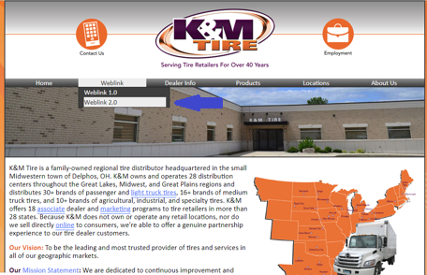

Enter Username and Password
- Login and Password exclusive to each customer. Passwords should be stored in a safe secure place. Passwords are only accessible by the customer assigned to them.
- Lost or forgotten passwords can only be recovered by clicking “Forgot Your Password” on the login screen. K&M Tire does not have access to customers' Weblink 2 password.

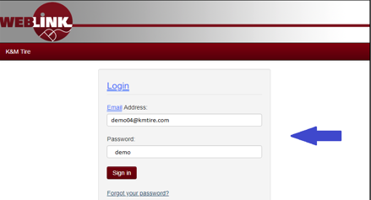

Home screen
The weblink home screen offers tools and information. Tire Rebates, Manufacture price increases, Promotions, and general posts. This information is located just below the search tire string. Scroll down on the home page to review all information.

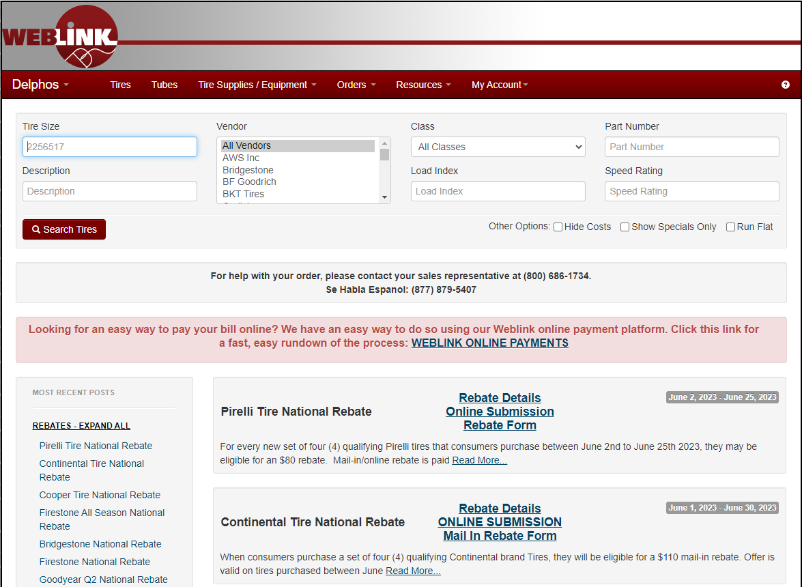

Transfer or PR Account
From the Home page when a customer has a transfer account or PR Account, they can toggle from their normal K&M Tire account to the given secondary account. (Transfer account or PR/SSP account)
Note: If a customer has the Toggle Feature make sure they understand how to choose the correct account.

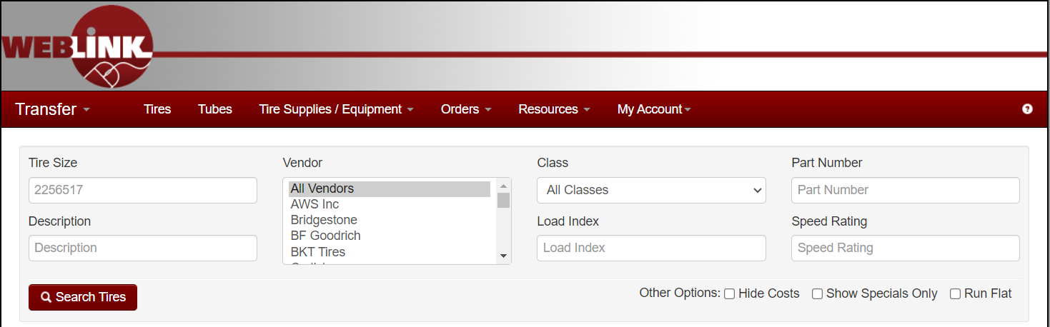

Tire Search
- When entering a size do not add any Letters, Dots, or Dashes. Just numbers in a string search EXAMPLE: (11225) or (2755520)
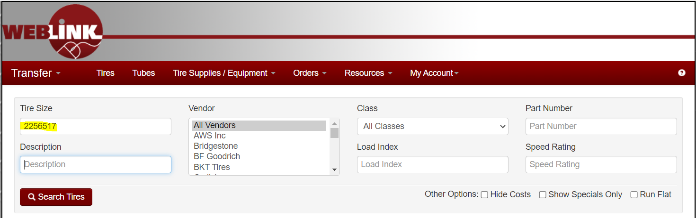
- The description bar can be used to help drill down specific models of tires. Example – If you’re looking for a tire with RT45 in the description. Place RT45 in the description bar and all tires with that RT45 in the description will show.
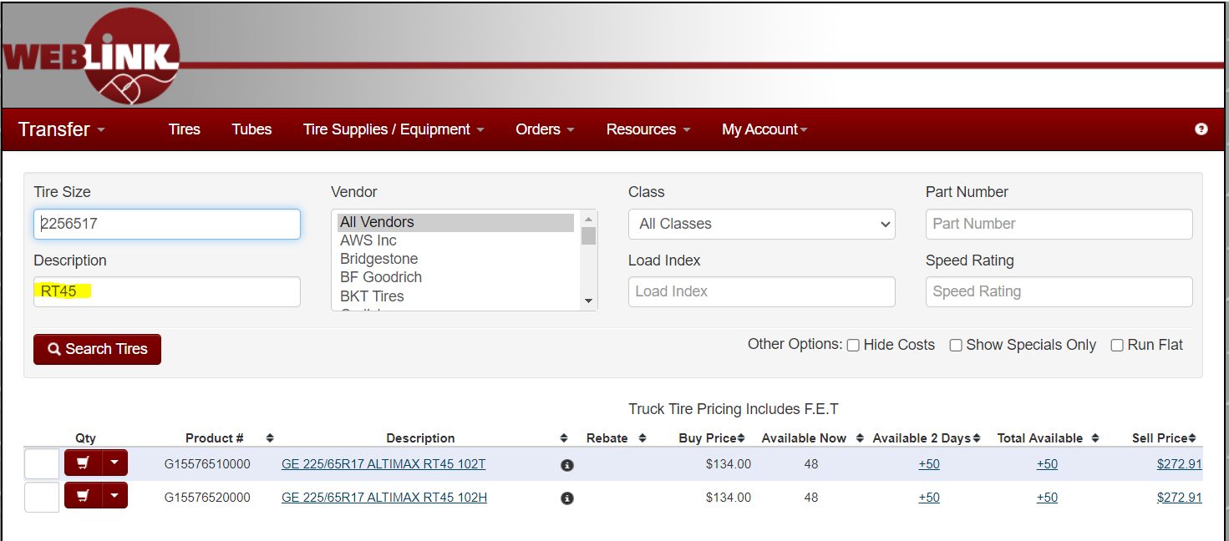
- Buy price can be adjusted by selecting the BUY PRICE tab, it will auto populate in either lowest to highest or highest to lowest buy price.
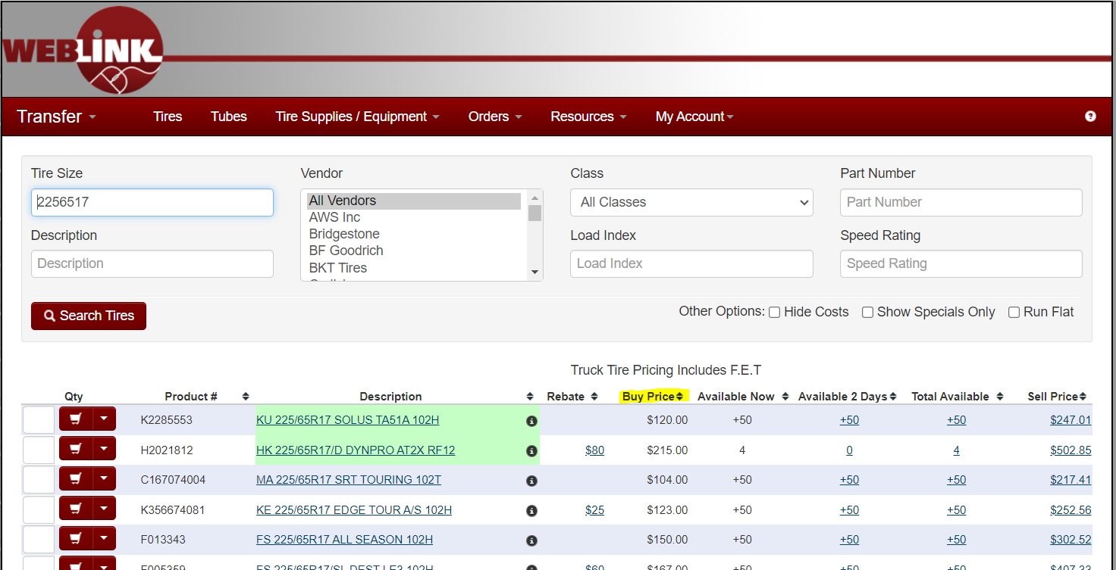

- Stock availability and location can be checked with the availability tabs. Click on the BLUE Inventory number and a drop-down box will appear. This will display the inventory’s location and how many days it will take to arrive.

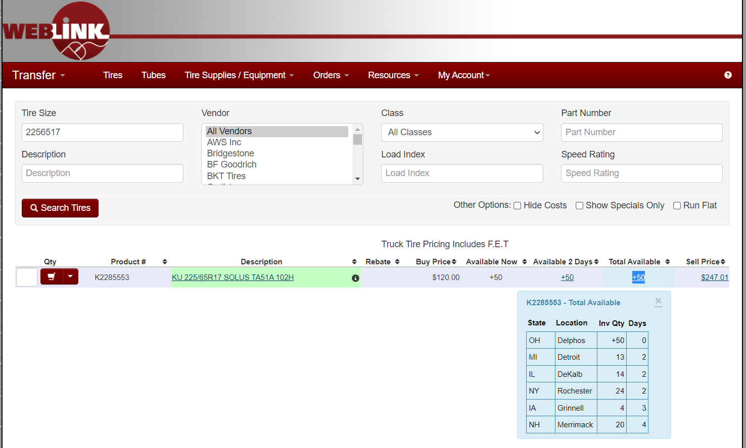
- Tire photos and specifications can be viewed by clicking the BLUE highlighted description link. This will display product specifications and the additional sizes offered in the product line.

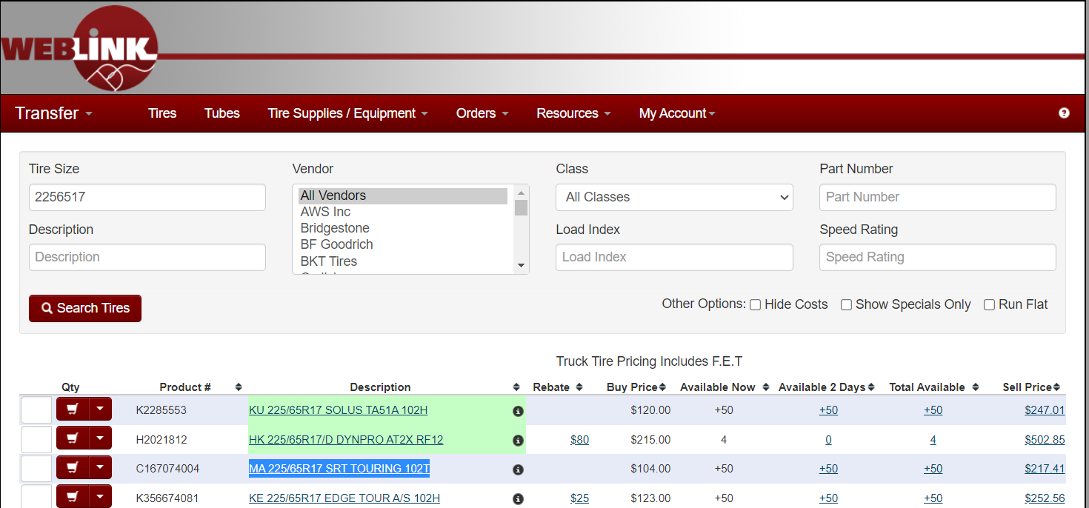
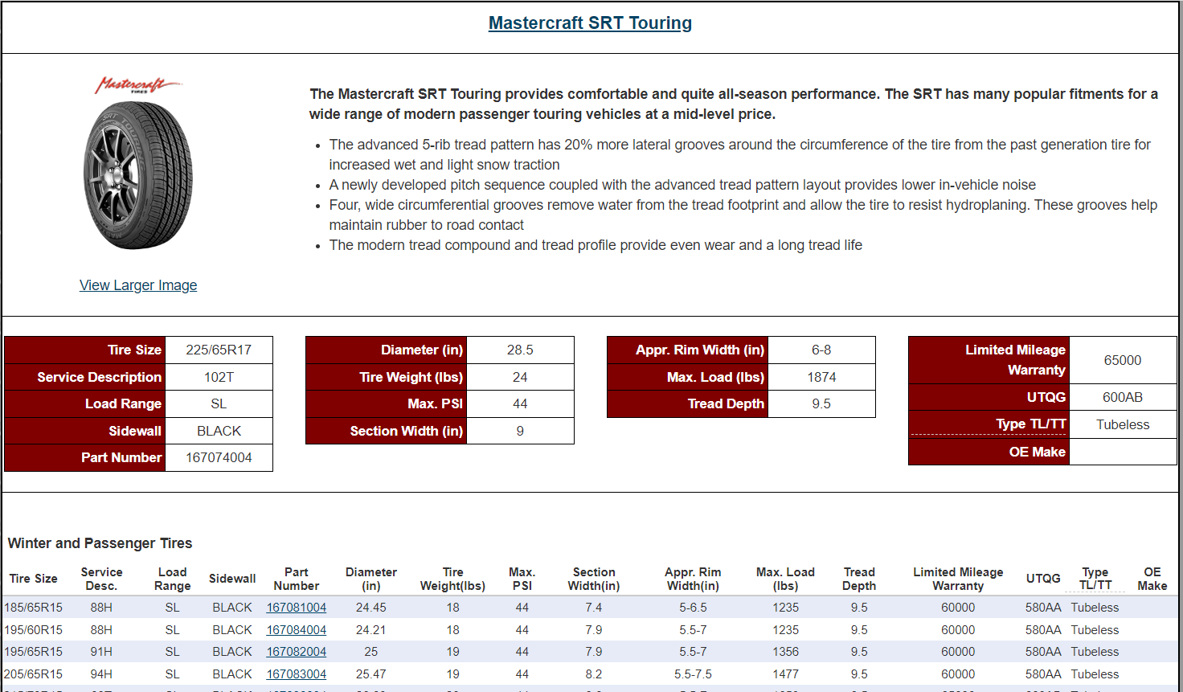

Search Options
Search options include brand, class, part number, load index, & speed rating. Example If you are looking ONLY for a Firestone. Select the brand and push the search tires button. Only the brand selected will appear. Follow the same steps for any of the other search options. You can use just 1 or a combination up to 7 like shown below.
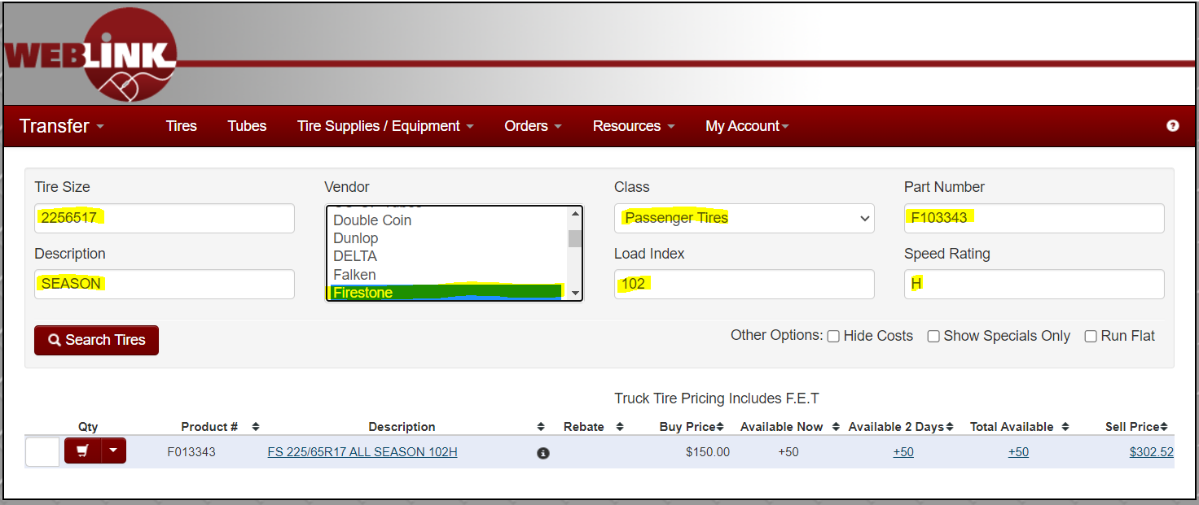

How to Order Product

- When the proper tire or product has been selected. Place the quantity desired in the square box to the left and hit the shopping cart.
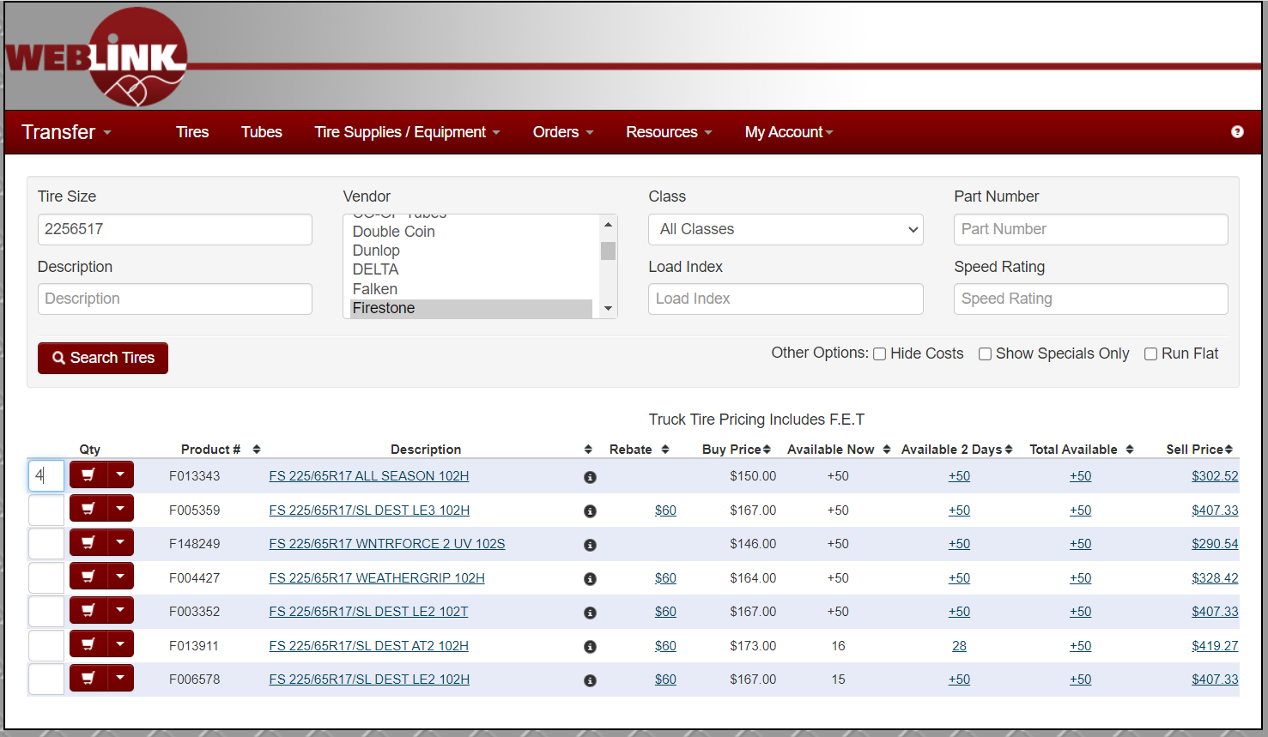

- The following screen will populate. You will be prompted to either ADD TO INVOICE, NEW INVOICE, or WILL CALL INVOICE. At this screen you can also enter a PO or Line notes.
- The order screen allows for adding multiple SKU’s or items to one invoice. (As long as it is coming from the same warehouse)
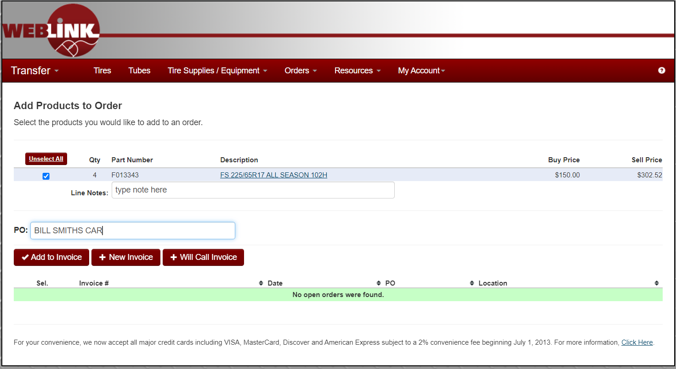
- Once you select New Invoice, Add to Invoice, or Will Call Invoice you will get a confirmation like below.
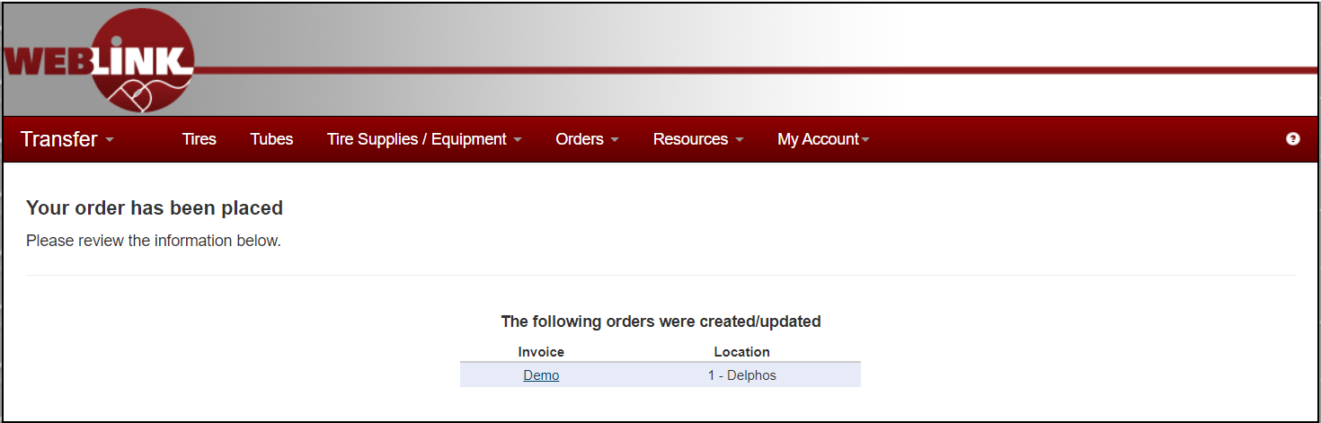

Tube Tab
- Tubes are search the same as tires. Type the size of the tire you are working with. (All Numbers no spaces, letters, dashes, or periods.)
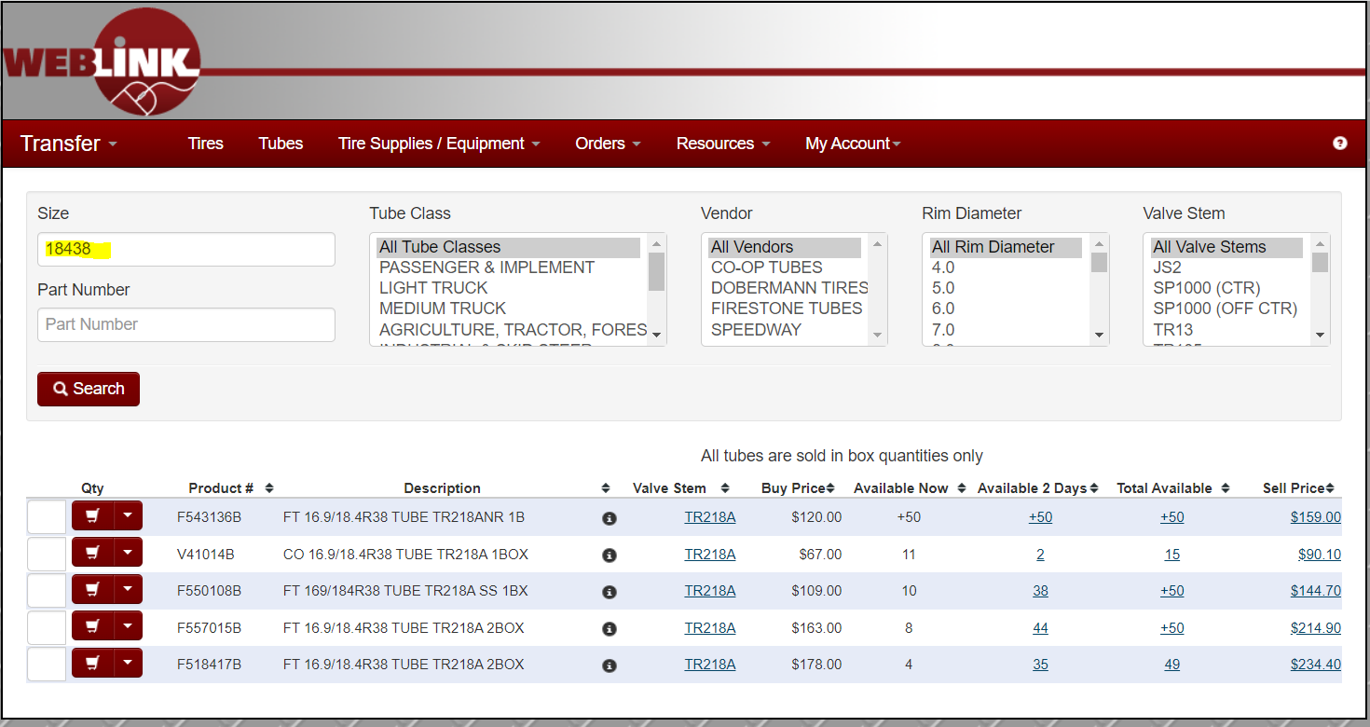
- You can click on the Valve Stem to see a picture of it.
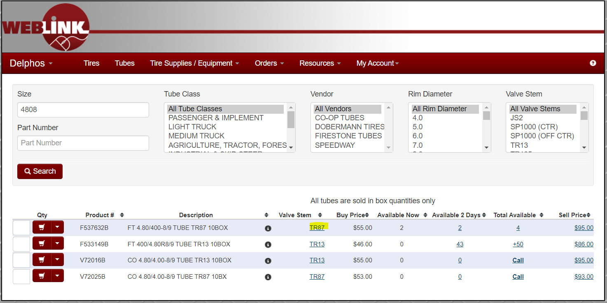
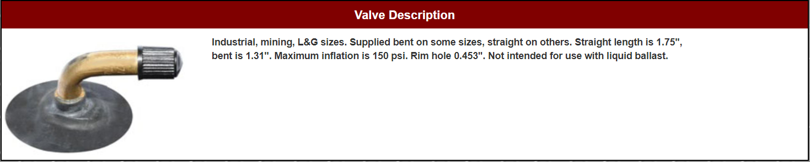

Wheel Search

- Searching for wheels is done from the Tires tab. Plug in W and whatever wheel diameter you are searching for. Example: If I am looking for a skid Steer wheel, I would put w165. W for Wheel and 165 because it is a 16.5 diameter wheel.
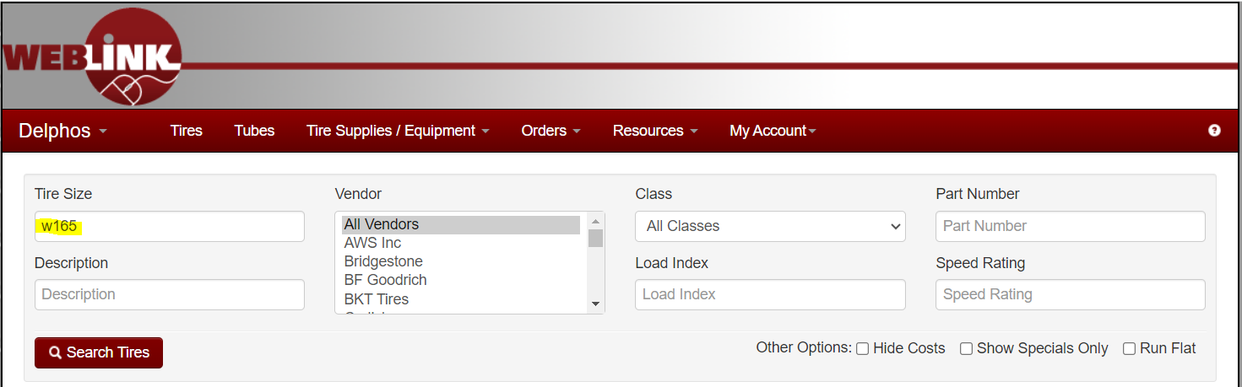
- You can also type in Description line CS, BC, NH, or JD to help narrow your search. CS is for Case, BC is for Bobcat, NH is for New Holland, & JD is John Deere
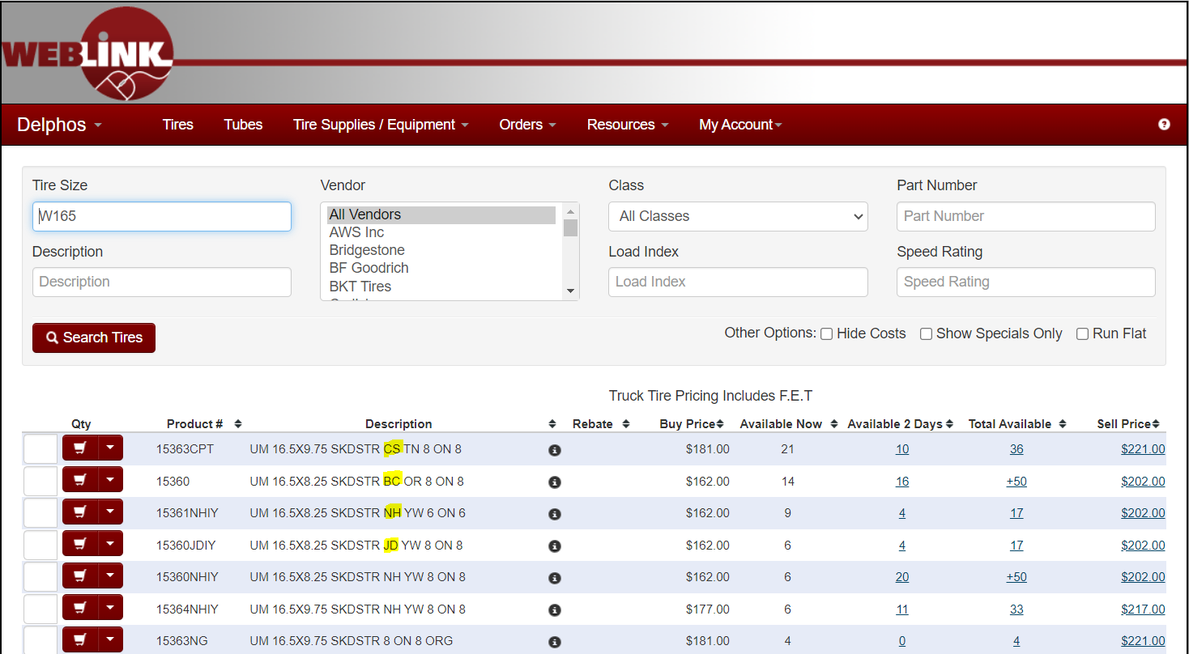

Tire Supplies / Equipment Tab

- The Tire Supplies / Equipment Tab has drop downs to narrow your search. If you know the part number or partial part number you can also enter that in Part Number field.
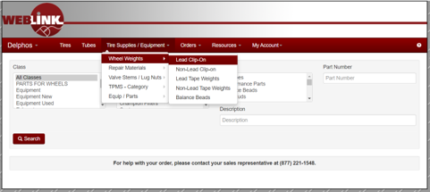

- If you know the part number or partial part number you can also enter that in Part Number field. Example: looking for 2.50 oz wheel weights, enter 250.

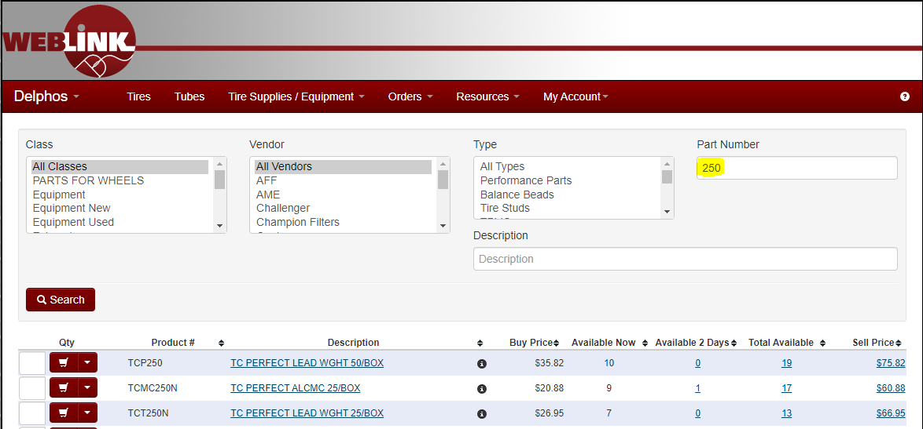
- If you know something that would be in the description, you can enter that in Description field. Example: looking for Balance Beads, Enter BEADS.
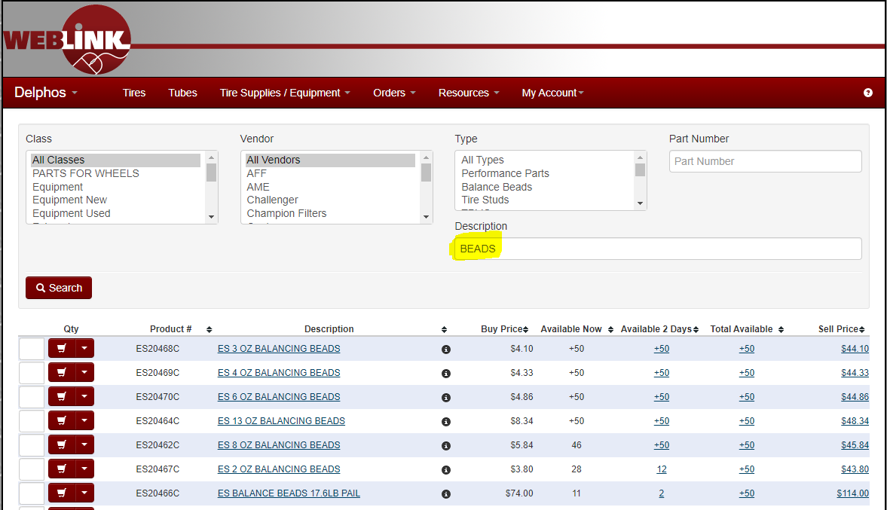

Orders Tab
The Orders Tab has a drop-down menu that allows you to select between Display Open Orders, Order by Part Number, Product History, or Quotes.
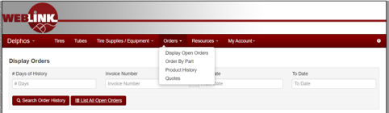

Display Open Orders
This will allow our customers to view orders that have not been processed yet.
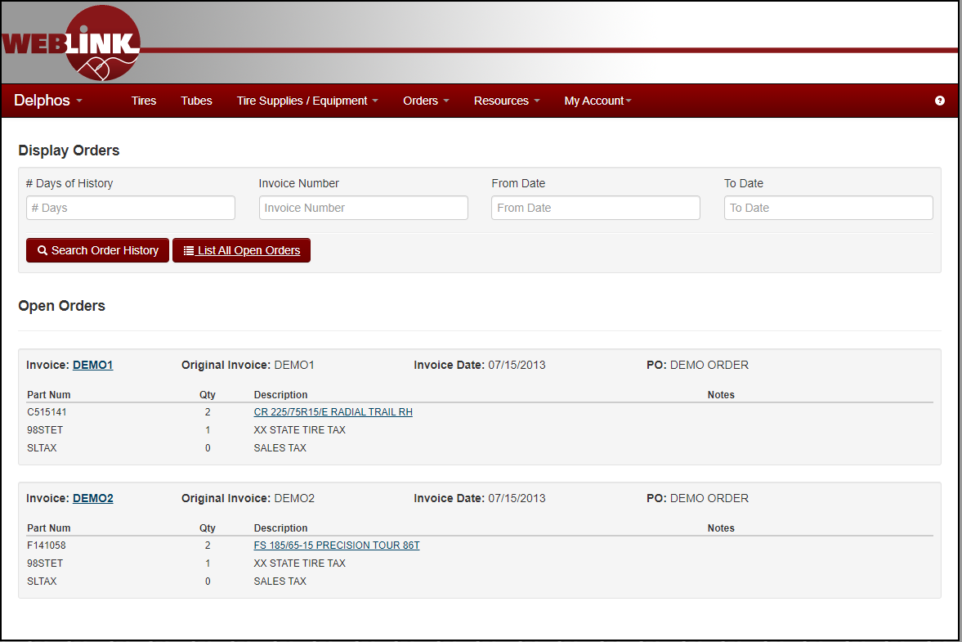

Order by Part Number
This allows our customers to order more items faster. They must enter the complete part number. Example below.
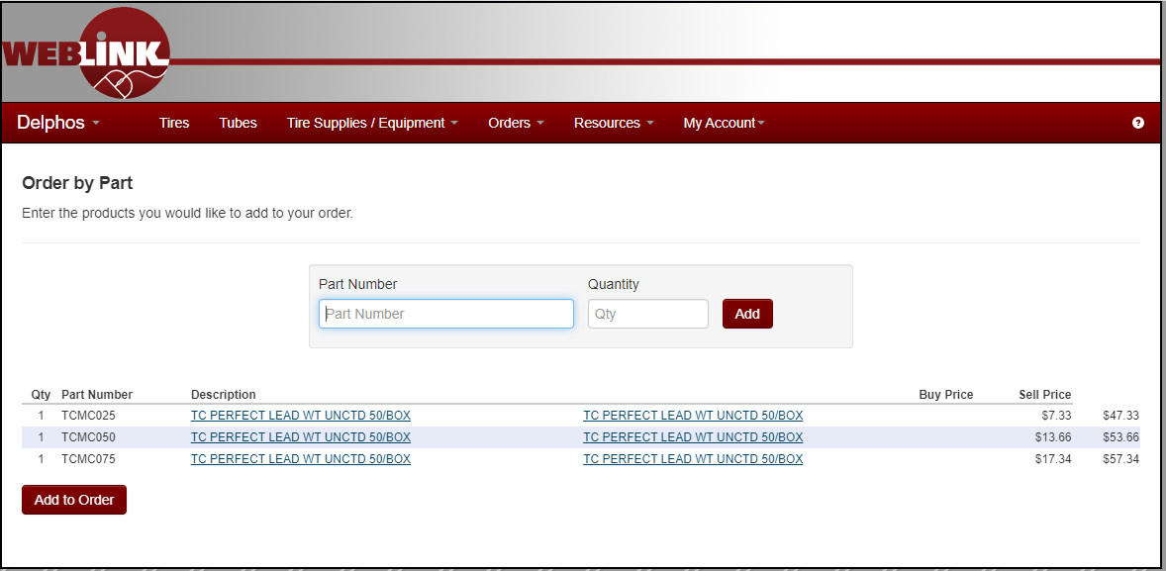

Product History
This allows our customers to look up history. They can choose size, part number, class, PO, Invoice Number.: Example below.
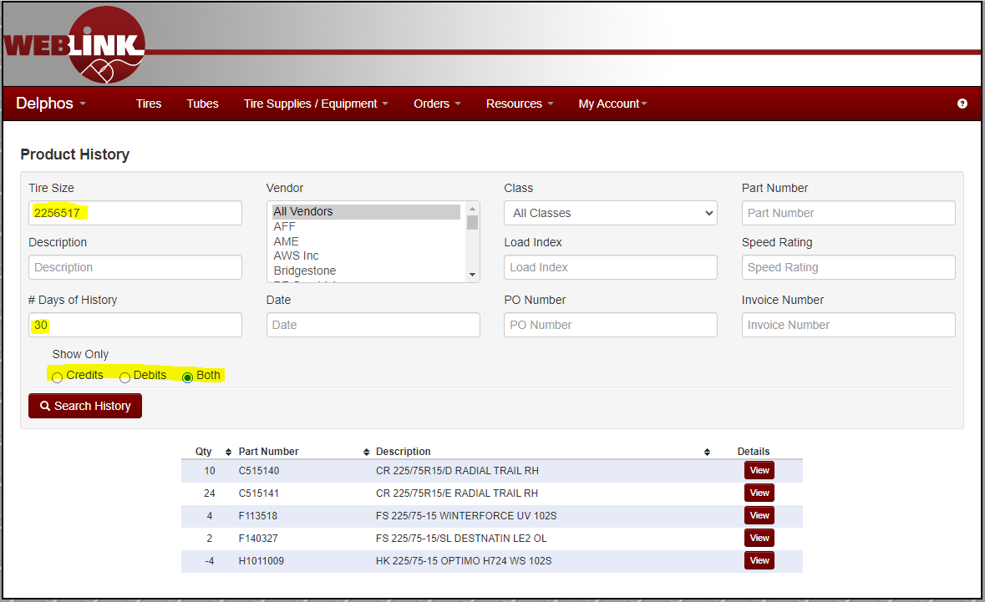

Quotes Tab
This allows our customers to look for quotes they created for their customers.
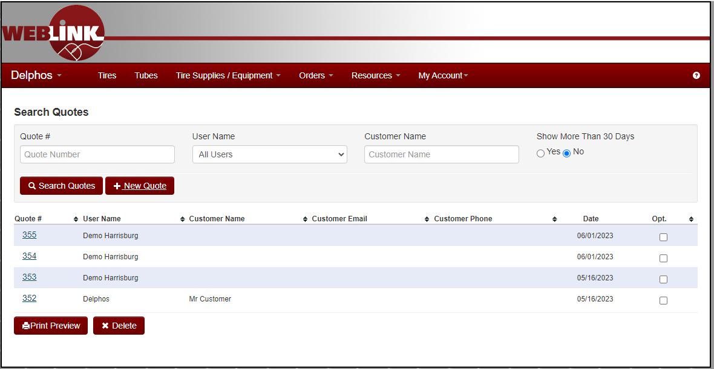
They can adjust the quote at this point or simply order the product from this screen.

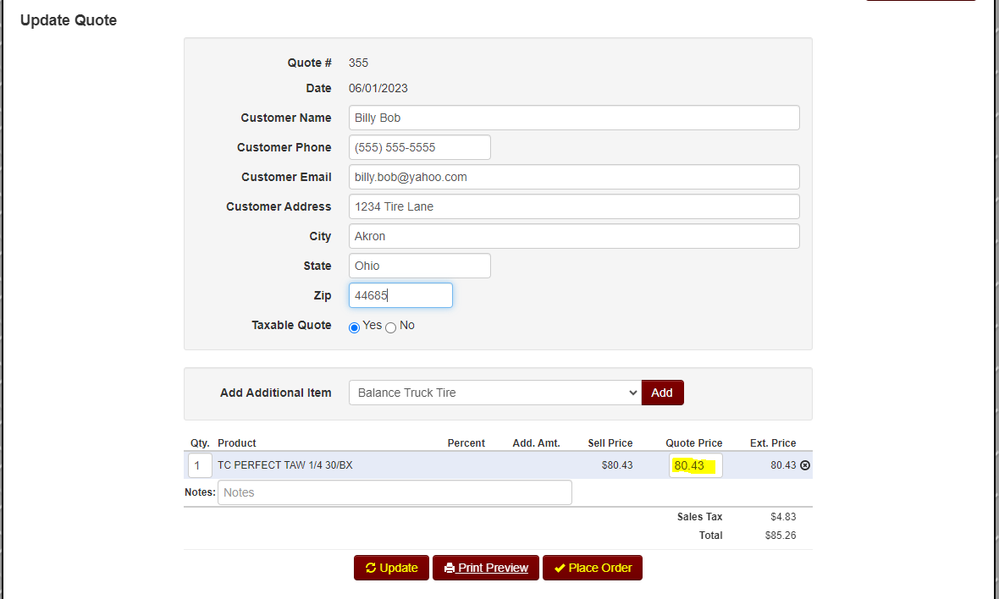

Resources Tab
The Resources Tab has a drop-down menu that allows you to select Tire Guide, Education, Equipment, Financials, Plus Fitments, Promotional Items, & Warranty Info.
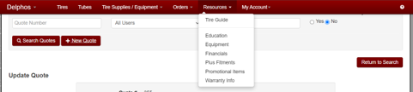

Tire Guide
Tire guide gives our customers the ability to quickly get all the import information needed to select the proper tire for their customer. Such as Size, Load Index, Speed Rating, Inflation, Rim Size, Torque Spec. & Bolt Pattern.
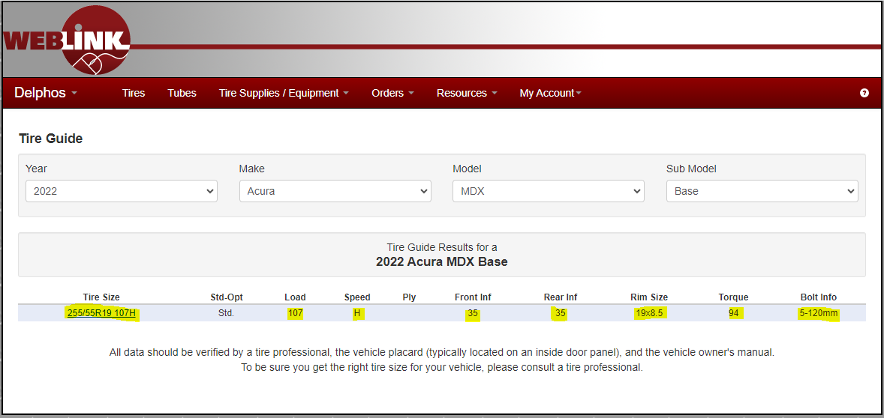

Education
Education is where our customers can find important tire related articles, training sites, TIA info, & tire related videos.

Financials
The Financials tab has a worksheet that will enable our customers to compare their business to industry averages.
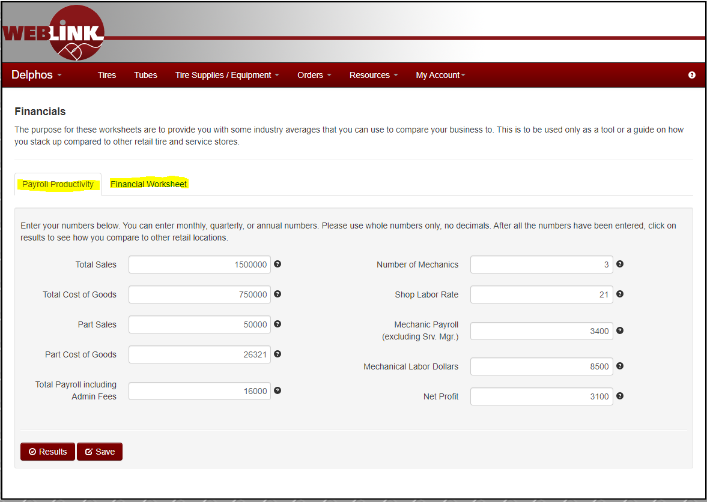

Plus, Fitments
Plus, Fitment tab allows our customers to find the best options for plus sizing in seconds. Put the OE size in, OD Tolerance, Width Tolerance, & what Wheel Size they would like to change to.
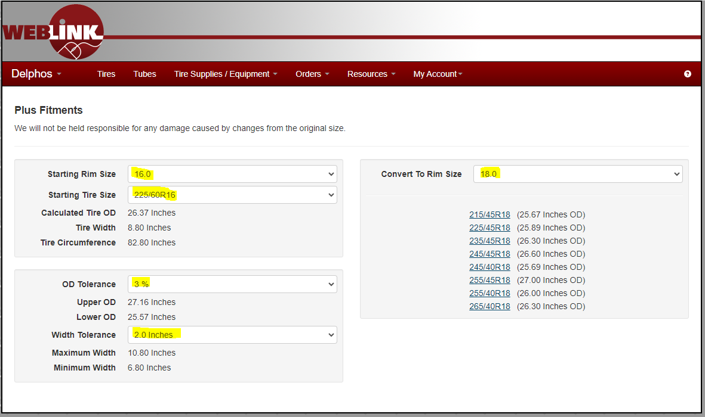

Promotional Items
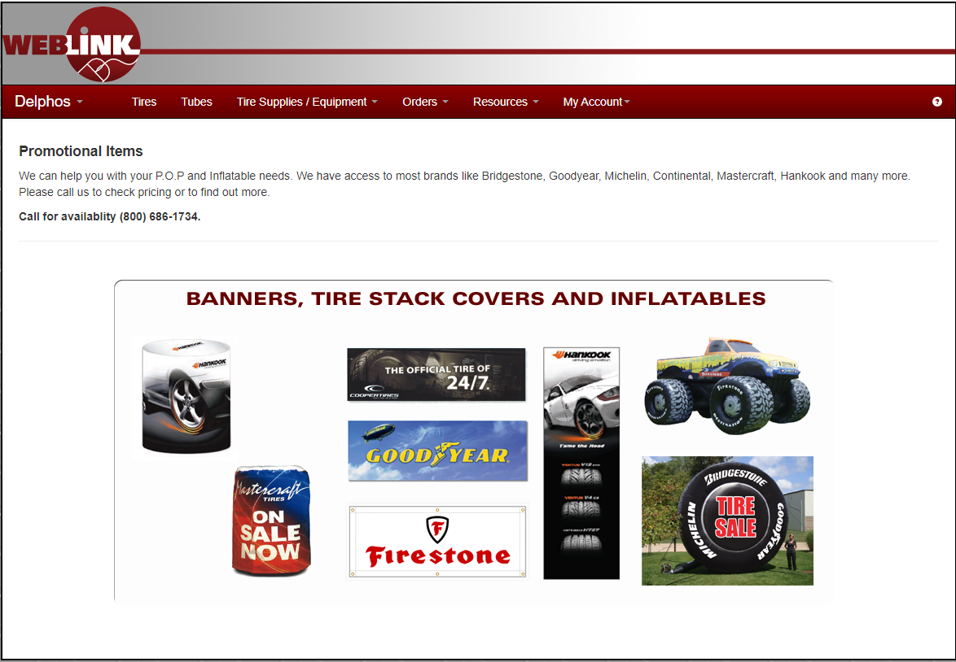

Warranty Info
Warranty info has All Classes, Brands, Tire Conditions Manuals, & Limited Claim Form Reference Guide.
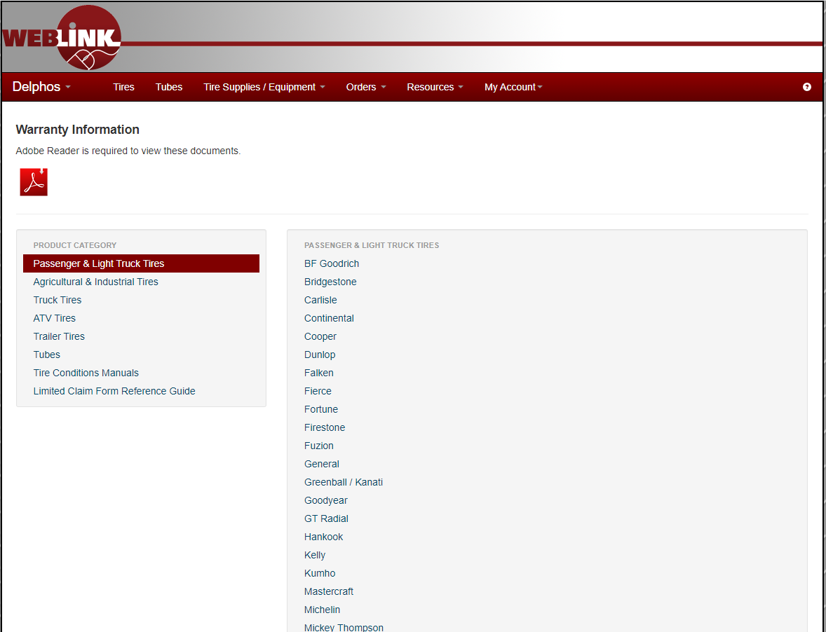

My Account Tab
My Account has a drop down including Make Payment, Invoices, Statement, Change Password, Feedback Help, Messages. Settings, & Logout
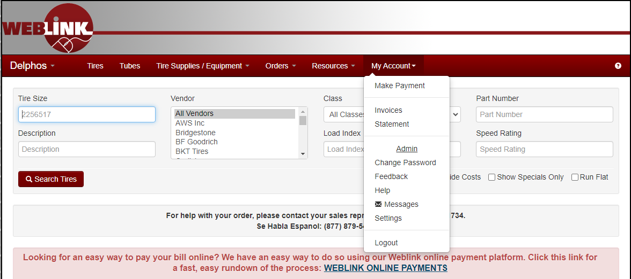

Make Payment
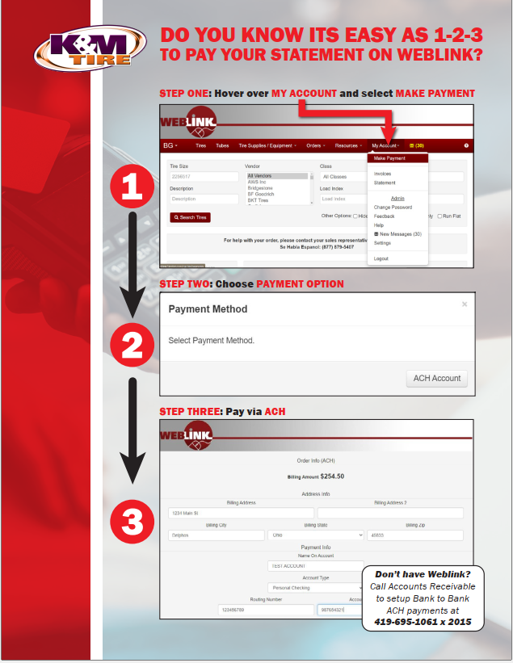

Invoices
Here is where our customers can lookup invoices by Invoice #, date range, & or # days of history.
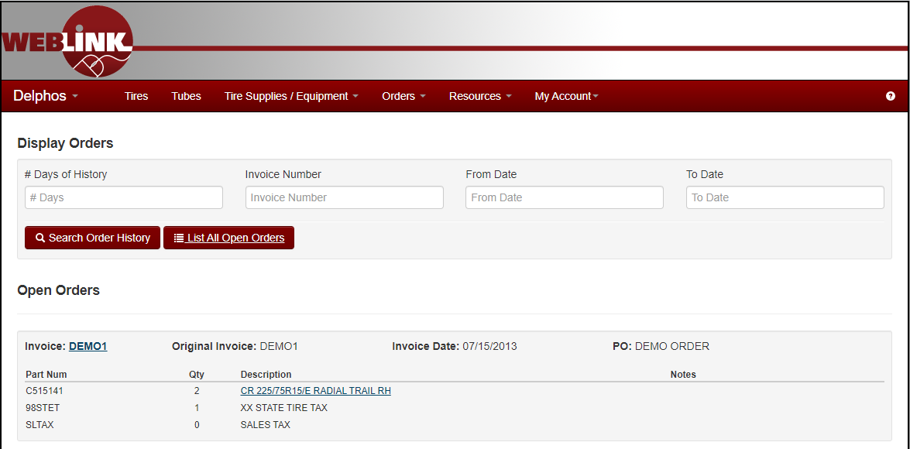

Statement
Here is where our customers can see their statement online.
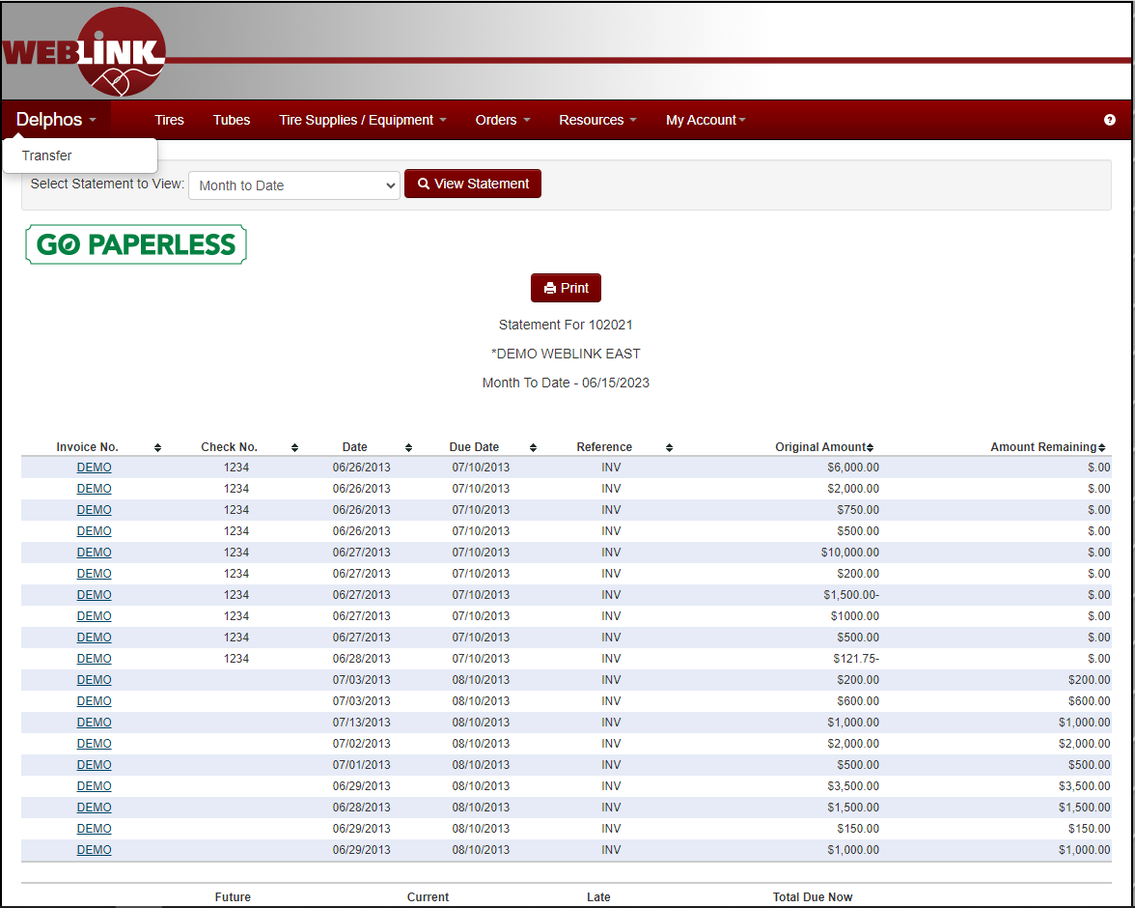

Change Password
Here is where our customers can change their password whenever they like.
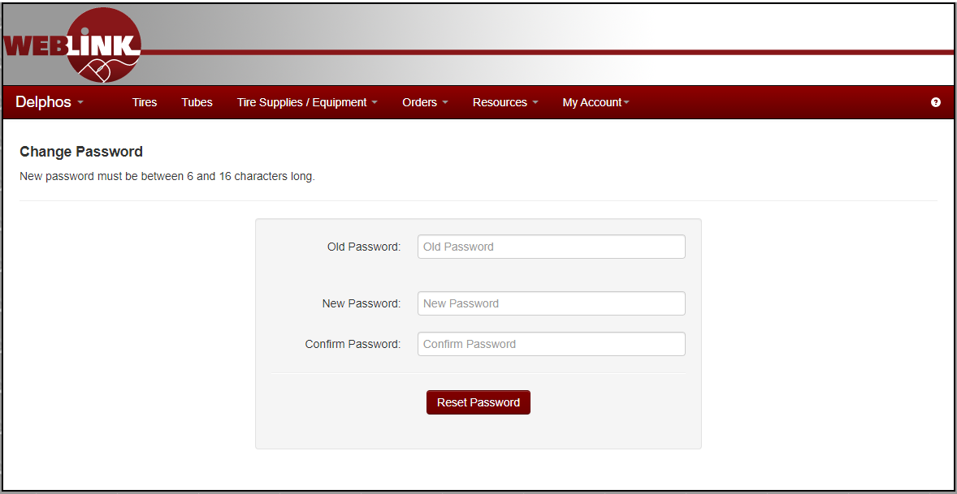

Feedback
Here is where our customers can give honest feedback good or bad.
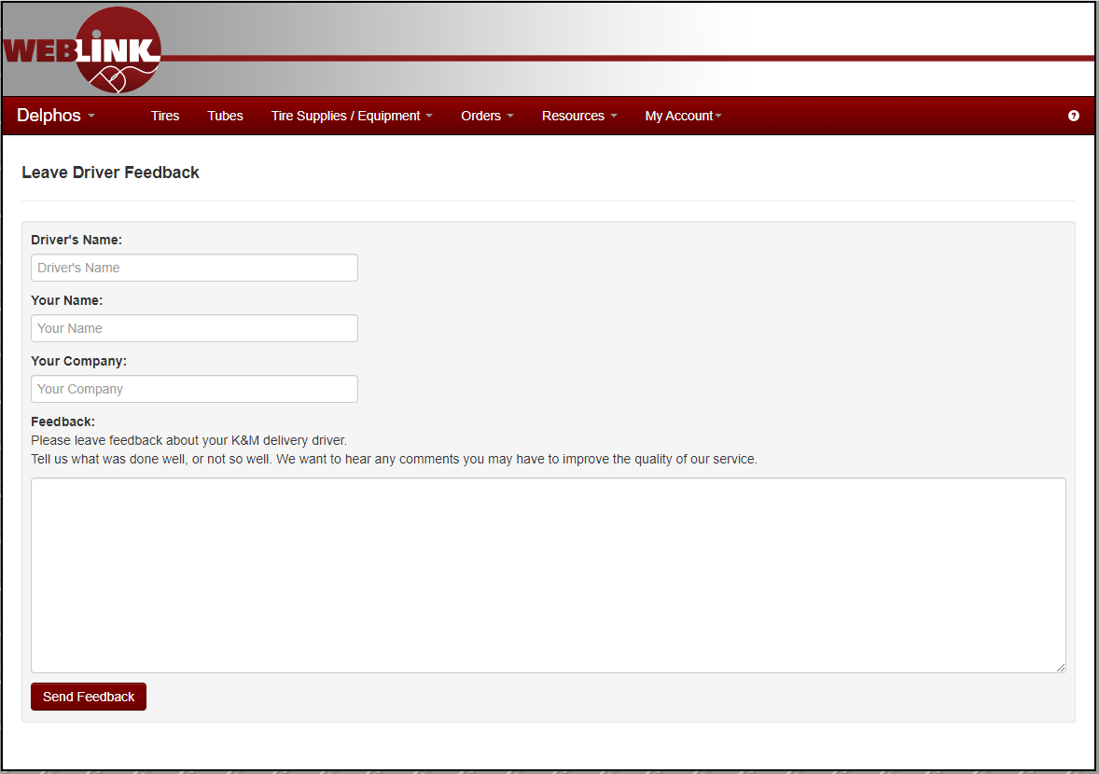

Help
Here is where our customers can find Help Videos, 101 Tips & Tricks, & How to Help.
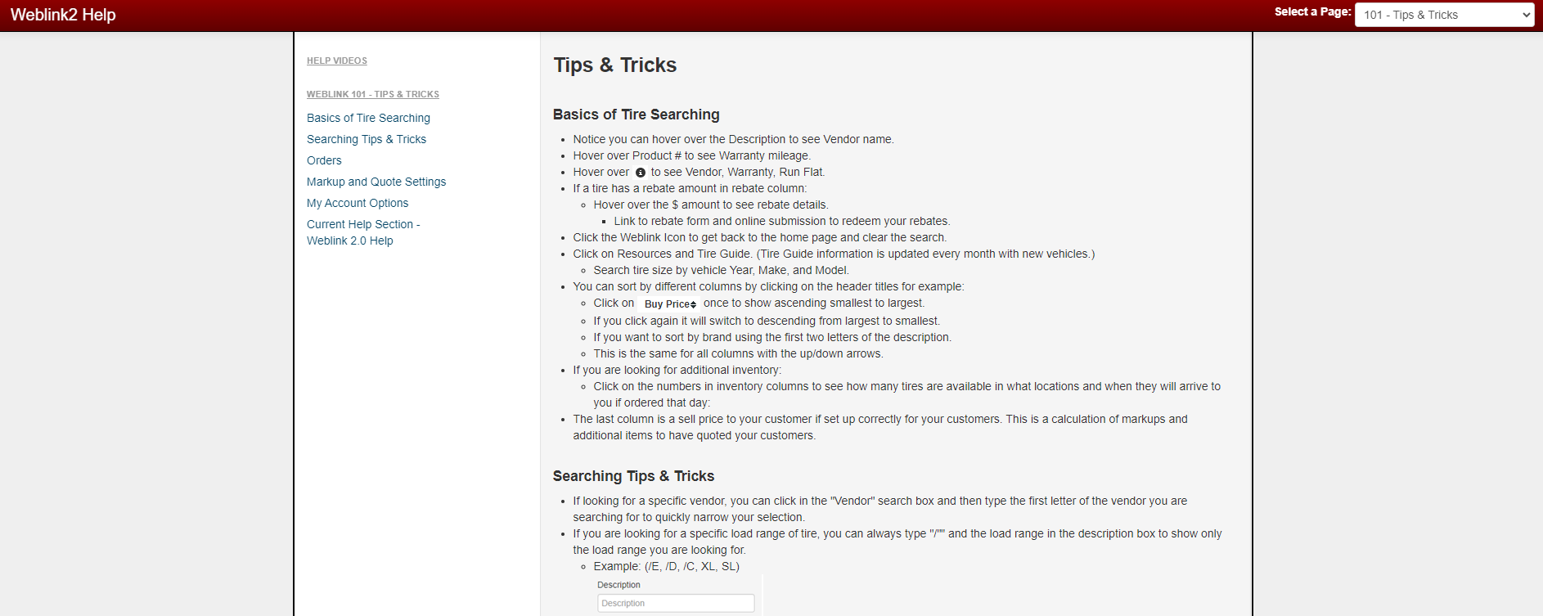

Messages
Here is where our customers can see messages to them or send messages to us.
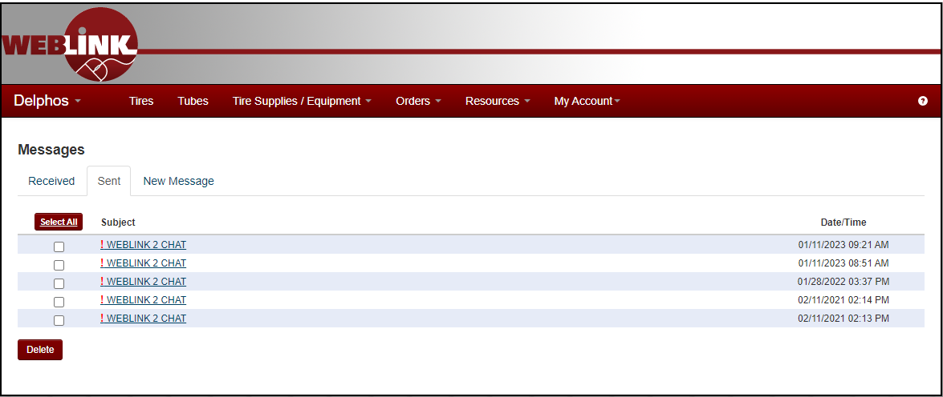

Settings
Settings are where our customers can customize Weblink 2.0 for their business.

User Settings
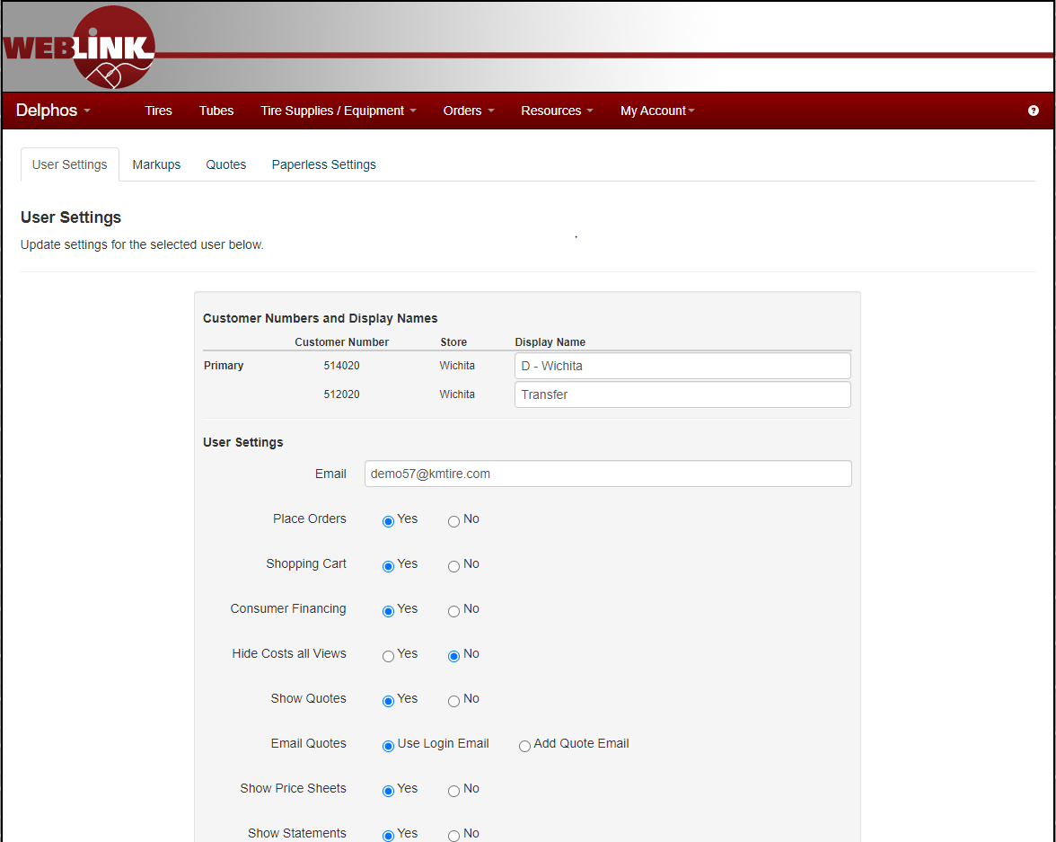

Markups
This is where our customers can add custom markups to make sure our quote feature corresponds with their POS system.
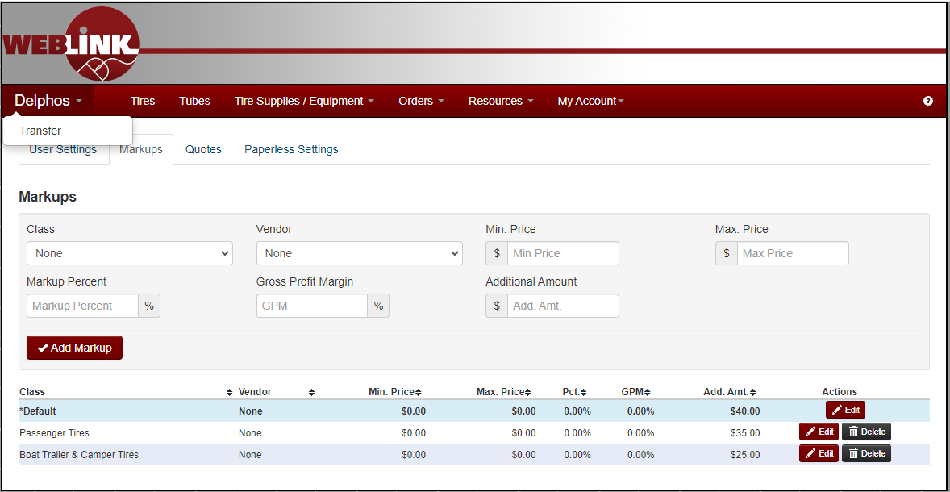

Quotes

Store Details
Here is where our customers will install their information such as Name, Address, Phone Number, Zip, & Sales Tax. This will ensure the quote feature works properly.

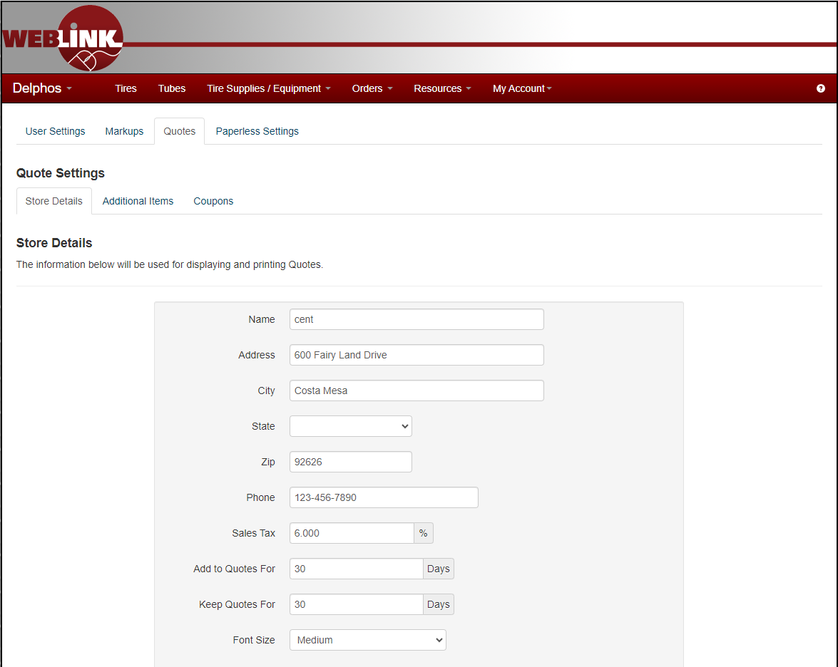

Additional Items
Here is where our customers can add commonly billed items. They can auto bill per invoice or per item. They can even create their own customized description.
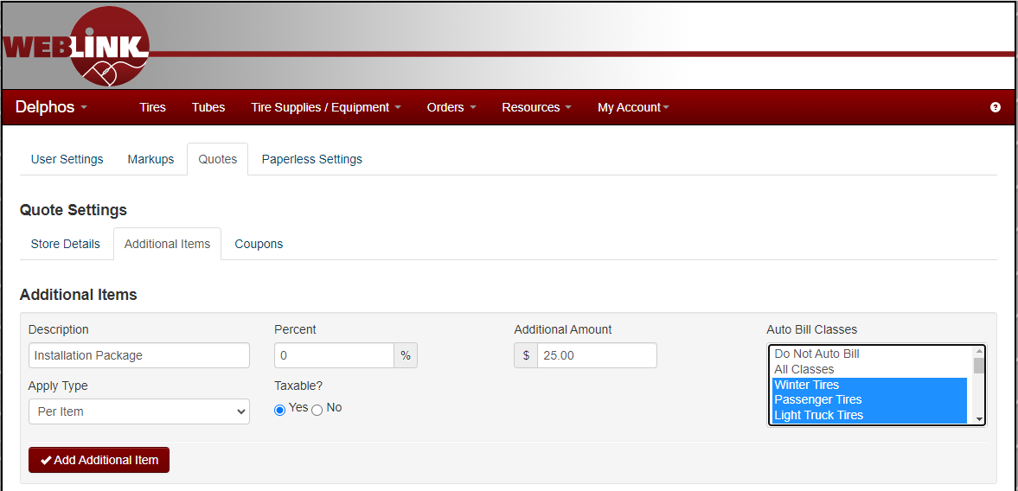

Paperless Settings

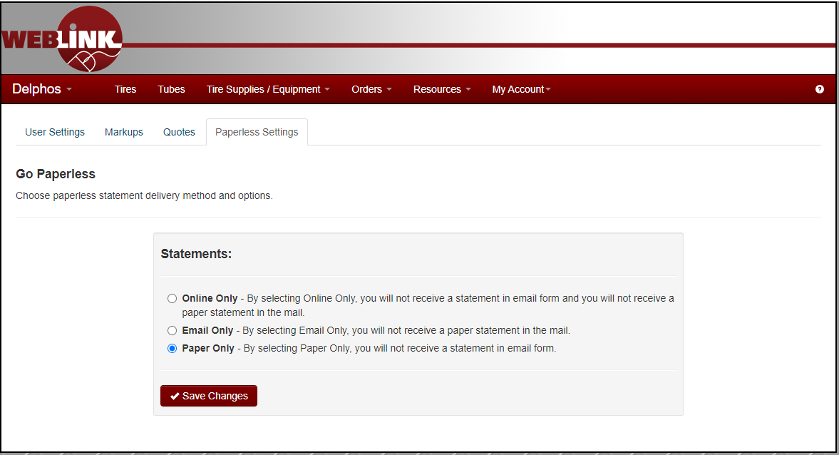

Intranet Best Practices
Training videos offering explanations on the following topics can be viewed by clicking below.
- F:\Sales\Public\Sales Rep Training\Sales SOP Help Videos

Ranking report, Weblink Login report, Vendor Programs report, Customer Information, Closed Order Search, Open Order Search, Sales Analysis, Inventory Control

Dashboard & MaddenCo Best Practices
Training videos offering explanations on the following topics can be viewed by clicking below.
- F:\Sales\Public\Sales Rep Training\Sales SOP Help Videos

Dashboard
Dashboard Outline: 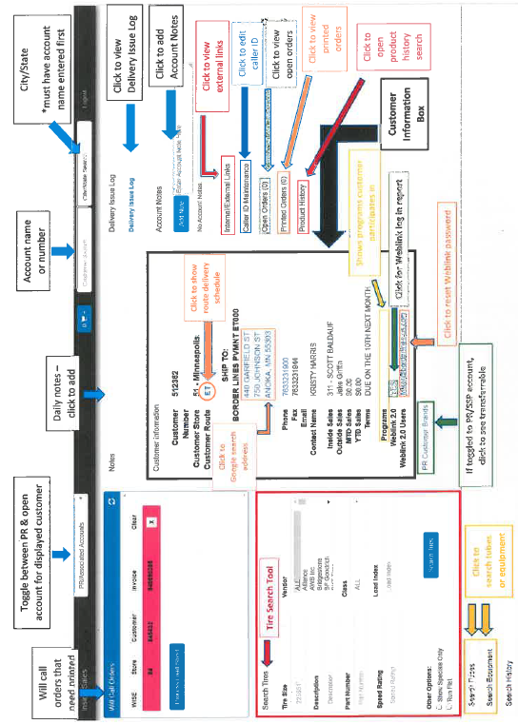
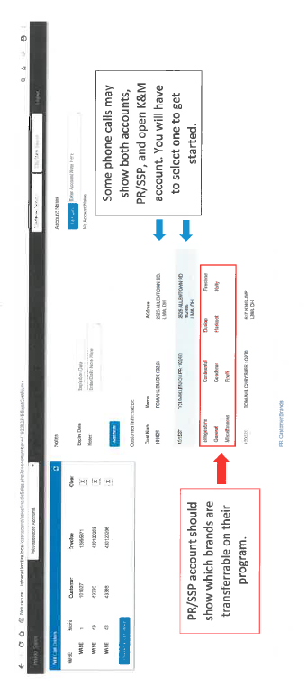

MaddenCo
MaddenCo serves many distinct functions in our company. It’s used in sales, accounting, and warehouses to name a few.
MaddenCo is accessible by clicking the Icon that look like this:
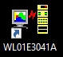 Or 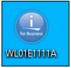
Your login name AND password will be your first name and last initial, all-in caps.
Ex. John Doe’s login name and password would be JOHND.

Sales Call Best Practices
As an Ag Sales professional you will encounter many different types of sales calls with different types of dealers. The following outline will help prepare you for some of those. Knowing that every tire dealer’s needs are different, my best advice is to keep an open mind. Just because a dealer sells a ton of farm tires doesn’t mean you should ignore discussions about Passenger/ Light Truck. Most people enjoy talking about themselves. Starting with an open-ended question such as, “How did you start your business?” is a great opener. You will learn things like what year they started, their family, likes, dislikes, and who they buy their tires from. Be prepared with something useful on every call. Customers know when salespeople are wasting their time and will disregard them from that point on. Be the professional they look forward to seeing because you give good advice and are efficient with their time. Remember always ASK FOR THE SALE.

Established Program Dealer
These dealers are the ones generating the bulk of the volume for the company. They are also the ones you will be most familiar with. Having a good relationship with these dealers is key. This relationship can develop into a personal one but does not have to. Personal, or simply business, here are some steps to consider for general calls on these dealers.
- Check recent purchase history with K&M to gauge if there may be changes in the relationship that you are unaware of.
- Check Telenotes for recent logs of interactions that you or another sales rep may have had with the dealer.
- Cover program performance for the period. Spell out the program goals for the period and make sure the dealer is aware and can adjust accordingly.
- Cover promotions and incentives, program related or not, currently available to the dealer from K&M Tire.
- Be prepared to do some prospecting with these dealers. Know what segments of the business K&M is not getting and show up with information to help. An example here would be that the dealer is a performing dealer on a passenger / light truck program with K&M and buys the majority of his/her passenger / light truck tires from K&M. However, K&M does not really get much for ST trailer tires from this dealer and we notice a competitor’s brand of ST Trailer tires sitting there from time to time. Do your homework on why the dealer gravitates toward that brand or distributor for ST trailer and be prepared to counter with alternatives from our product screen.
- Cover the general state of business with the dealer. Find out what is working for them and what isn’t. Are there areas where they need help? If so, is there help K&M can provide? You may find there is help we might be able to provide, but some homework is required. You now have good ammunition for another call and the opportunity to tie the dealer to K&M even more.

Established Dealer / Program Prospect
These dealers are the ones at the front of the line to join the group above. These dealers are either smaller ones that may fall under the radar for program presentations or larger ones who are programmed up with other distributors. Regardless, a key objective is the same…find that opportunity where we can sign them on a program that they will achieve with. Sometimes a program is just not an option, and we need to focus on a product segment or K&M fulfilling the role the dealer has identified us for.
- Check recent purchase history with K&M to gauge if there may be changes in the relationship that you are unaware of.
- Check Telenotes for recent logs of interactions that you or another sales rep may have had with the dealer.
- Check the Weblink Login report for dealer activity.
- Having done your homework, start or continue a conversation with the dealer about the program opportunity you have identified that could help them. If nothing else comes of this the dealer knows you are trying to find ways to help them make more money and this adds value to your relationship.
- If a program is not an option, focus on a product segment(s) where K&M can be the primary or a key supplier. This is an area where you can do some prospecting again. An example would be that there is a large commercial dealer that is direct with Michelin, Goodyear, and Continental, but buys some Tier 3 and Tier 4 truck tires from K&M as needed and based solely on price and availability. In talks with dealer, you find out that they service a large fertilizer company that also shops them for highway service implement tires for anhydrous ammonia tanks. The dealer has no direct relationship with the ag tire manufacturer and sells little in ag tires but supplying this large customer of theirs with these tires is key to them keeping the truck business they have. Your expertise, or availability to access the expertise within K&M for the ag segment will move the relationship forward.
- Cover the general state of business with the dealer. Find out what is working for them and what is not. Are there areas where they need help? If so, is there help K&M can provide? You may find there is help we might be able to provide, but some homework is required. You now have good ammunition for another call and the opportunity to tie the dealer to K&M even more.

Current Prospect
These are the dealers currently not doing business with K&M (they may have an account set up). These dealers will vary in size and type dramatically. With this group, you will need to reference your planning on where you prioritize a specific dealer. The priority of the dealer will determine the frequency of sales calls and areas of emphasis in the call.
K&M Tire Ag reps can help the company grow in one of two ways. We can grow existing business or we can add new dealers as active customers. We need to do both. Here are some practices to use with current prospects.
- Check Telenotes for recent logs of interactions that you or another sales rep may have had with the dealer.
- Do some internet searches for the dealer. Note any changes regarding products being promoted in relationship to the dealer.
- If the dealer is set up with an account but not buying anything, check the Weblink Login report on Intranet. If they are looking, then you can go down the road to find out why they are not buying it and adjust accordingly. If they are not looking find out why. Have they lost their Weblink username or password? Do they use shop software that accommodates distributor inventories and orders, and K&M is not showing?
- If the dealer is not set up with an account, then be prepared for each call to rectify that. As you called on them before, you should have the general information needed to complete much of the Credit or COD (COLLECT ON DELIVERY) application. Consider having a copy with you, fill out as much as possible, and then present it when the opportunity presents itself during the call. Be sure to go over the advantages of doing business with K&M during the call.
- Cover the general state of business with the dealer. Find out what is working for them and what isn’t. Are there areas where they need help? If so, is there help K&M can provide? You may find there is help we might be able to provide, but some homework is required. You now have good ammunition for another call and the opportunity to tie the dealer to K&M even more.

New Prospects – First Call
Adding new dealers to K&M Tire as customers starts with the very first sales call with the dealer. This could happen after extensive planning and on the spur of the moment as you see them while driving or get a referral that you want to jump on right away. Here are some key practices to employ in these calls.
- In other sections we will cover the research practices, so we will just assume you identified a dealer that does sell tires and is a potential customer or K&M Tire.
- Go in and introduce yourself! Get it out of the way. If not obvious, ask to speak with the person who would be responsible for considering another supplier.
- Gauge the moment while you are there. Take cues from the receptiveness of the dealer on what type of presentation to make. Are they swamped? Brief is best. Are they engaged in the conversation? Be prepared to change tactics during your presentation to better suit the conversation.
- Have a business card with you when you go in. If nothing else, leave that with the person you spoke with.
- Offer up the opportunity to complete a credit application while you are there. You can offer to fill out the obvious parts if it helps. You may have to leave it with them. If you do not carry one in with you, have it readily accessible in your car so that if you must step out to get it you can be right back inside. You can also show them where to access on www.kmtire.com or offer to email them over a copy.
- Take note of what you see and hear during the presentations. Often during the first call the dealer isn’t willing to offer up much information, but your eyes and ears can collect a lot. Is the place well-kept or a mess? Are there lots of staff or just 1 or 2 people there? What tire brands are displayed or sitting around? Do they have invoices on the counter or desk? If so, where are they from if for tires? Cues like these can help you format a more formal plan for follow up calls.

Commercial and/or Ag Focused
Listed below are a few questions you may ask yourself when pre-call planning for Commercial or ag customers:
- Is this dealer providing in field AG/OTR tire service?
- Is this dealer providing Mobile tire service for trucks?
- What is their monthly/annual purchase potential?
- Are they capable of $100k or more in annual AG/OTR purchases?
- Are they capable of $100k or more in annual commercial truck tire purchases?
- How can K&M tire enhance their business via programs or technical tire solutions?
- What are some barriers of entry to earning this customer's business?
- What might you be able to do to set yourself apart from the competition?
- Are they listed on any of the manufacturer dealer locators?
These are some questions you will want to consider with each call. Any K&M rep can make these calls, and these are good questions for all. If you are not a Commercial or Ag Sales specialist and think you need help with a call on these types of dealers, reach out to your manager or your region’s Commercial or Ag Sales specialist.

Manufacturer Programs
Historically, Firestone was one of the only manufacturers to have any sort of program for Ag tires. In recent years, some of the import brands have begun participating in annual or quarterly programs to encourage dealers to sell more of their product. It will be important to track progress and potential candidates for the following manufacturer programs:
- Firestone CAD (Certified Associate Dealer)
- BKT Growing Together Associate Dealer
- Trelleborg Associate Dealer

Key Talking Points
Whether it be the first introduction or a long-time customer, there are many key talking points to be had when making ag sales calls. Listed below are a few talking points that can be used to better understand a key customer’s needs.
- Are they currently enrolled in any manufacturer programs?
  - You may have found them through one of the dealer locator websites mentioned.
- What is their current servicing area and who do they compete with?
  - Knowing what they competition is selling may help make brand recommendations.
- What is the largest tire that they can service?
  - Depending on the region, this could be a factor in your decision to focus on the account.
- Are they having issues finding the correct sizes/fitments from our inventory or competition?
  - Part of your role is to provide feedback on missed opportunities to stock.
- What sort of issues are their customers having?
  - Do they need help with tire failures/warranties or in field adjustments?
- Are they aware of new products, technology, or technical training that is available?
  - We can connect dealers to a manufacturer training event or conduct our own with their staff on site.

Forms
Brief videos offering explanations on the following forms can be viewed by clicking below.
- F:\Sales\Public\Sales Rep Training\Sales SOP Help Videos

Credit Application
There are a variety of forms that may need to be filled out for a dealer to do business with K&M Tire. An account application (credit or COD application) is required for any dealer to have an account set up with K&M. The account application works for both a charge account and COD account. Only page 1 is required for a COD account to be set up. The 2nd page would need to be completed (at least in part) for charge account consideration. Get with your manager or Credit department with specific questions about the account application or note the video referenced below. Completed account applications should be sent to the K&M Credit department. Spanish language account applications are also available.
Following, you can find examples of the bare minimum necessary information for account ser-up.
If a customer is exempt from Sales Tax, be sure to have them complete the following information, or legally we will be required to charge them sales tax (a copy of their state issued Sales Tax Exemption Certificate is acceptable as well).
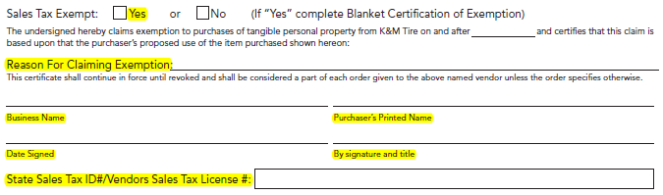
Reason for claiming exemption should be “resale” in most cases.
Click here for the most up to day version of the credit application:
- F:\Credit & Collections\Public\Credit

For COD Account, the following highlighted information is necessary for account setup.
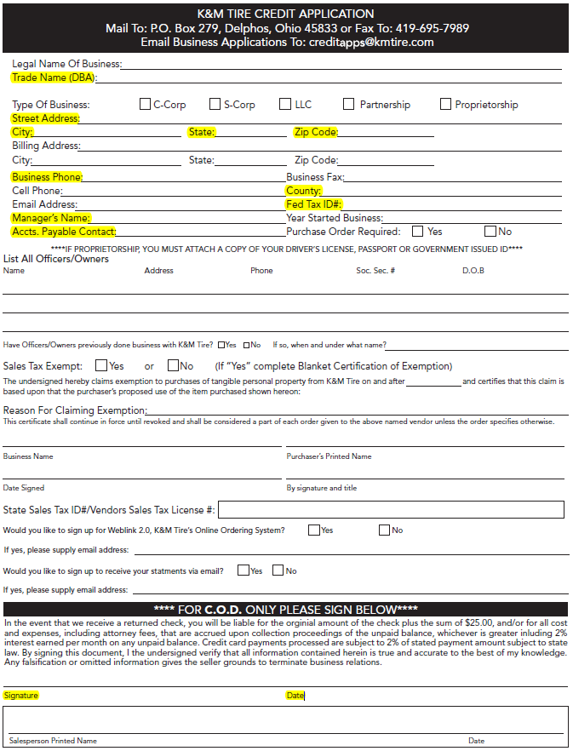
For Charge Account: the highlighted info is required for account setup and consideration for a Charge Account.
Page One:
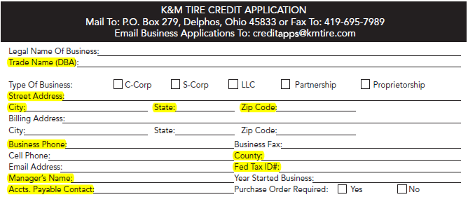

Page Two:
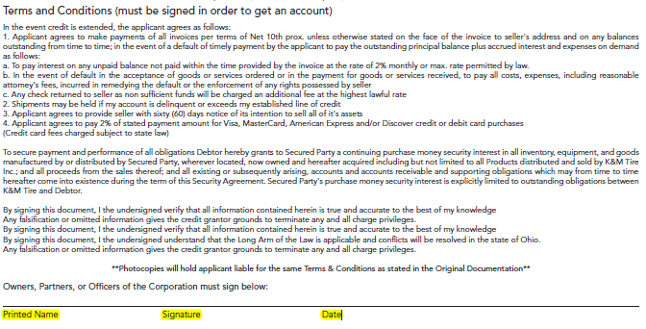
Spanish Credit Application

- F:\Credit & Collections\Public\Credit

Common Ownership
Many dealers have multiple locations. If we have a customer with other locations currently not set up with K&M Tire and the locations fall within our service area, we can set the locations up using a form called the Common Ownership Form (if locations operate under the same federal tax # as current customer location). If there are questions about the use of this form, please get with your manager or the Credit department or note the video referenced below. Completed common ownership forms should be sent to the K&M Credit department.
Common Ownership Form
- F:\Credit & Collections\Public\Credit

Dealer Request
You will often find that a dealer has a direct relationship with a tire manufacturer which may allow K&M to act as a supply point for some brand(s) related to that manufacturer. If allowed, we would then set up a PR (purchase / resale) account or SSP (secondary supply point) account. To accomplish this, we must obtain some information about the potential account and record it. We do this by using the Dealer Request form and sending it to the K&M marketing department and K&M Credit department.
Dealer Request Form
- F:\Credit & Collections\Public\Credit

Release of Liability
We sometimes have dealers that are open at odd hours or happen to be in a location that our trucks deliver to before the dealer opens or after the dealer closes. In these instances, a dealer may choose to give us permission to leave products at a specified place at the dealer's location if the dealer is not available to sign for receipt. A dealer can give us this permission by completing the Release of Liability (ROL) form. A dealer should only complete this form if he or she has confidence that the products left will be safe. K&M can only assure us that products will be left per the terms of the form completed. If there are questions about where and when to use the ROL form, please get to your manager or the K&M Credit department. Completed ROL forms should be submitted to the K&M Credit department.
Release of Liability Form
- F:\Credit & Collections\Public\Credit

Price Level Change Request
We understand the necessity to be price sensitive in all our markets. K&M Tire makes every attempt to ensure our pricing is competitive but knows there are times when we must address pricing issues due to market pressures. The tool we have available to us to accomplish this is the Price Level Request. There is an accompanying request form required to be completed with every Price Level Request.
The Price Level Request form (sometimes called PLR) asks that you provide as much detail as possible regarding the pricing pressure in play. This includes example pricing from competitors, brands or classes involved and a comment section to explain the reasoning behind the request. Please provide as much information as you can on the form. This makes your manager’s job much easier in accessing the request and then much easier for corporate management to approve.
The timeline works like this with PLRs.
- You are made aware of pricing issue with a customer.
- Meet with customer to secure as much competitive information as you can (sometimes difficult to accomplish)
- Gather competitive pricing from other means if possible (your manager can help you with suggestions).
- Complete the PLR form, save it, and email your manager.
- Your manager will access the form, make changes if necessary and then forward on to corporate management for a final level of approval or send it back to you or deny.
- If forwarded on to corporate management, the PLR is further accessed and either approved or denied. Your manager will receive notice of either.
- If PLR is approved the final step that is often overlooked is to be sure to get back with your customer and inform him or her of the changes you had put in place and what the expectations are to keep those changes in place.

You can access blank copy of the Price Level Request (PLR) form here:
Price Level Change Request Form
- F:\Sales\Public\Sales SOP

Dealer Programs
K&M Tire and our vendor partners have created a variety of programs for eligible dealers to participate in. The programs provide things like training, point of purchase materials, dealer rewards and even incentives to counter sales staff. These programs all have two primary focuses. They are intended to provide incentives to dealers to help the dealer sell more tires and to create a sense of loyalty to the program so more tires associated with that program are sold vs. others.
It is a key focus for K&M sales staff to support the effort of evaluating dealers for program participation and then helping those dealers that are eligible to select a program that they can succeed on. After a dealer is signed onto a program the emphasis with that dealer and program changes to helping make sure the dealer maximizes the various parts of the program, so the dealer realizes the greatest benefit possible from participation.
Below is a list of the various programs K&M Tire offers us or in conjunction with our vendor partners.

Goodyear G3X
- \\10.73.0.6\File Server\Marketing - Programs\Public\Manufacturer Programs\Goodyear\G3X

Goodyear Tire & Service Network
- \\10.73.0.6\File Server\Marketing - Programs\Public\Manufacturer Programs\Goodyear\Tire & Service Network

Bridgestone BARNN
- \\10.73.0.6\File Server\Marketing - Programs\Public\Manufacturer Programs\Bridgestone\BARNN

Yokohama Advantage
- \\10.73.0.6\File Server\Marketing - Programs\Public\Manufacturer Programs\Yokohama\Yokohama Advantage

Cooper Medallion
- \\10.73.0.6\File Server\Marketing - Programs\Public\Manufacturer Programs\Cooper

Mastercraft Century
- \\10.73.0.6\File Server\Marketing - Programs\Public\Manufacturer Programs\Mastercraft

Kumho Premium Fuel
- \\10.73.0.6\File Server\Marketing - Programs\Public\Manufacturer Programs\Kumho

Hankook ONE
- \\10.73.0.6\File Server\Marketing - Programs\Public\Manufacturer Programs\Hankook

Falken Fanatic
- F:\Marketing - Programs\Public\Manufacturer Programs\Falken

Mickey Thompson MTMA
- F:\Marketing - Programs\Public\Manufacturer Programs\Mickey Thompson MTMA

Nexen Next Level
- F:\Marketing - Programs\Public\Manufacturer Programs\Nexen

BKT Growing Together
- F:\Marketing - Programs\Public\Manufacturer Programs\BKT

Trelleborg Associate Program
F:\Marketing - Programs\Public\Manufacturer Programs\Trelleborg\Associate Program

Goodyear G3X Commercial
- F:\Marketing - Programs\Public\Manufacturer Programs\Goodyear

Hankook School Bus/Government
- \\10.73.0.6\File Server\Marketing - Programs\Public\Manufacturer Programs\Hankook

Yokohama Commercial Advantage
- \\10.73.0.6\File Server\Marketing - Programs\Public\Manufacturer Programs\Yokohama\Yokohama Advantage

Cooper Pinnacle TBR
- \\10.73.0.6\File Server\Marketing - Programs\Public\Manufacturer Programs\Cooper

K&M Specific Program Request
MR. Tire/ Big 3
- F:\Marketing - Programs\Public\K&M Programs

Tool Utilization

Laptop

Regulations

The computers, telephones and all voice/data services provided by the Company are primarily for business use to increase productivity and provide customer service. However, limited, occasional or incidental use of these tools for personal, non- business purposes is understandable and acceptable. All such activities should be done in a manner that does not decrease productivity or be in direct conflict with your supervisor’s expectations on how you are performing your job duties. It is advised to speak with your supervisor to determine their expectations on performance levels while using these tools for personal use. The expectations of the Company regarding personal use of tools provided are to demonstrate a good sense of responsibility and not abuse this privilege. Outside e-mail activity including Hotmail, Yahoo or any personal e-mail accounts on company-supplied equipment will not be allowed, as it poses a security threat from viruses. Also, any streaming media such as music, radio, videos, or movies over the internet will not be allowed. Unauthorized downloading or installing of any software is prohibited. Employees should contact an I/T representative if they have any questions. The Company reserves the right, at its discretion, to review/monitor any employee’s phone activities, electronic files and messages to the extent necessary to ensure all voice/data services provided by the Company are being used in compliance with the law, this policy and other Company policies. Employees should not assume voice/data services are completely private. Accordingly, if employees have sensitive information to transmit, other means should be used. All authorized computer system users have been assigned a "log-on" that identifies them to the computer system. No one is to use the computer system that has not been assigned a "log-on" and no one is to use a computer terminal that is logged on with another user's identification. Since the Company holds authorized computer users responsible for all data processed through the system under their username/password, users should log off the system when leaving their terminal and change their password frequently to maintain acceptable levels of security. The computer system is an extremely expensive investment for the Company and contains all the Company’s accounting information, all of which is confidential.

Cell Phone

Regulations

This policy applies to the use of personal and company cell phones, wireless handheld devices (such as Tablets & Smart phones), MP3 players, iPods, and other electronic equipment. All personal devices that are not property of K&M Tire should not be plugged into any K&M Tire computers, networks or any other equipment unless approved by an I/T representative. The use of a personal cell phone on Company time is permitted only for emergencies, during scheduled breaks or with supervisor approval. Unauthorized downloading or installing of any Apps is prohibited on company supplied devices. Employees should contact an I/T representative if they have any questions. Camera phones may not be used to take pictures in the workplace without prior authorization by the manager. Company cell phones are provided for business purposes. If you have a Company cell phone, you must keep personal use to a minimum; you may be required to reimburse the Company for excessive personal use. Use of a Company cell phone is a privilege and is not a right. Such use may be denied, revoked, or restricted at any time for any reason without notice. AN EMPLOYEE HAS NO RIGHT TO, AND SHOULD HAVE NO EXPECTATION OF, PRIVACY IN THE USE OF THE COMPANY’S CELL PHONES. The company may monitor company cell phone usage and document or record communications, to the extent permitted by law. If you use a Company vehicle with a gross vehicle weight of 10,000 or more pounds, you cannot use your cell phone while driving unless you are using a company-approved hands-free device. Federal law states that all handheld cell phones are banned while driving to reduce distracted driving. Unless using a company-approved hands-free device, you must pull over to a safe place before making or receiving a call. Drivers may face fines if caught using a cell phone and all fines are the employee's responsibility.

Expenses
The expense report is to be submitted by the 15th of the month when your new bank statement is available.

What is covered?

Meals

Meals are covered when there is an overnight stay. All food and drink items are covered except alcohol. No alcohol permitted. Receipts should be submitted through the Concur expense section 03 Meals and Entertainment. All receipts must be itemized. Meals per day are covered up to a max of $40.00 combined.

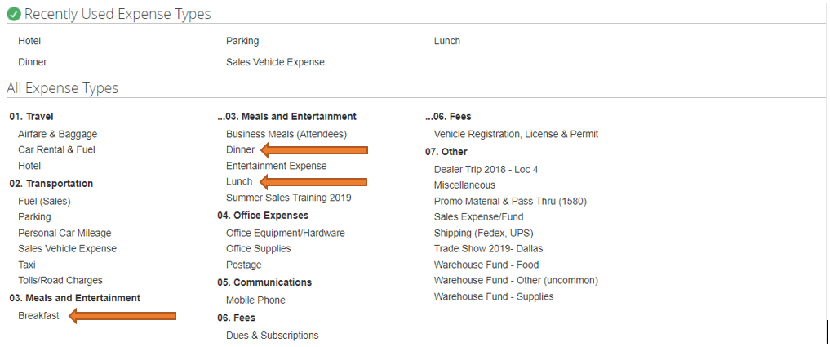

Hotels
Hotels are covered for employees traveling for work purposes. Any stays totaling in excess of $120.00 taxes included need to be approved by management. The receipts should be submitted through Concur expense in section 01 Travel.
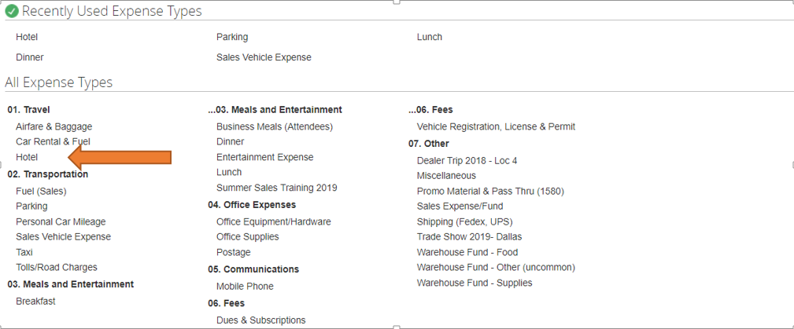

Fuel
Fuel should be purchased with the fleet cards provided in each company vehicle. Company employees can use their personal fleet card ID to purchase fuel in company vehicles. Please do not use major truck stops.
If a noncompany vehicle is being used fuel will be reimbursed by submitting the receipt through the Concur expense in section 02 Transportation under Fuel (Sales).
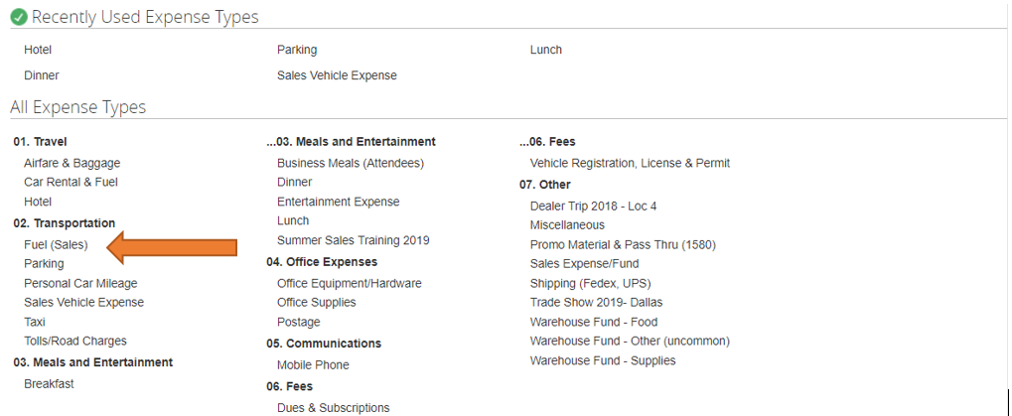

Customer Entertainment
Customer Entertainment expenses will be covered for tickets to sporting events, concerts, golf etc. The expense will be reimbursed by submitting the receipts through Concur expense section 03 Meals and Entertainment under entertainment expense. If there is food served it is reimbursed under Business Meals (Attendees). Expenses exceeding $100.00 will need prior approval from management.
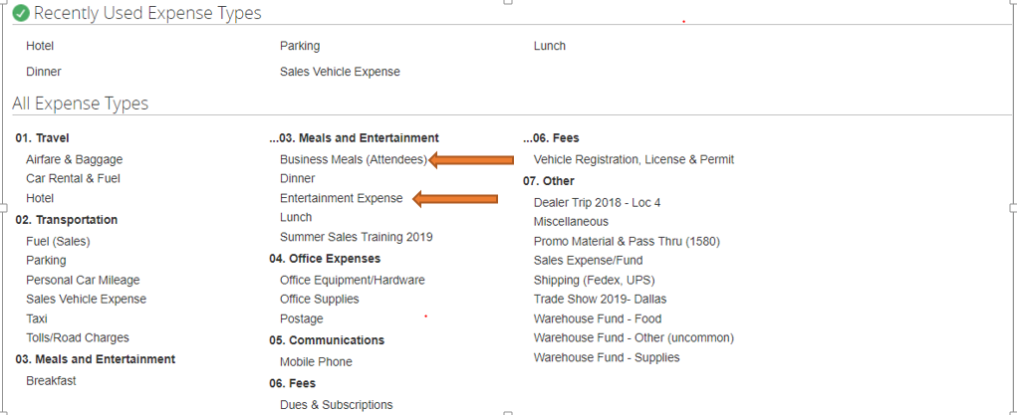

Concur – Expense Report Submission

Log on to Concur at https://www.concursolutions.com
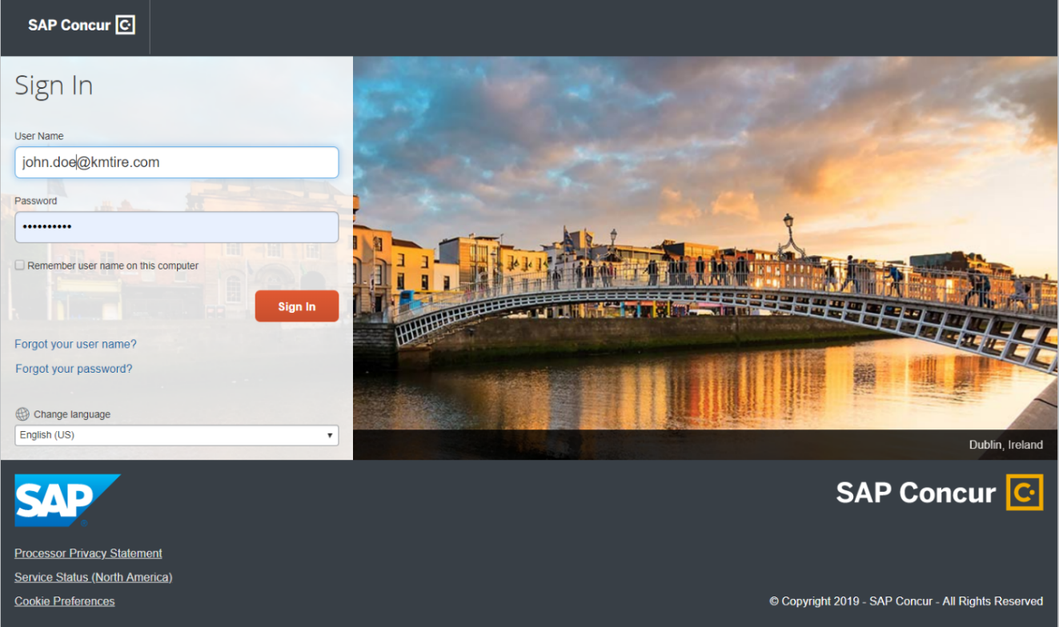

Creating a new Expense report
- On the home page, on the Quick Task Bar, place your mouse pointer over NEW, and then Click START a REPORT
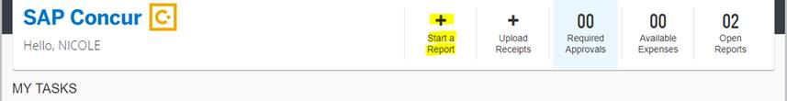

- Complete required fields report name, date, and business purpose and select next.

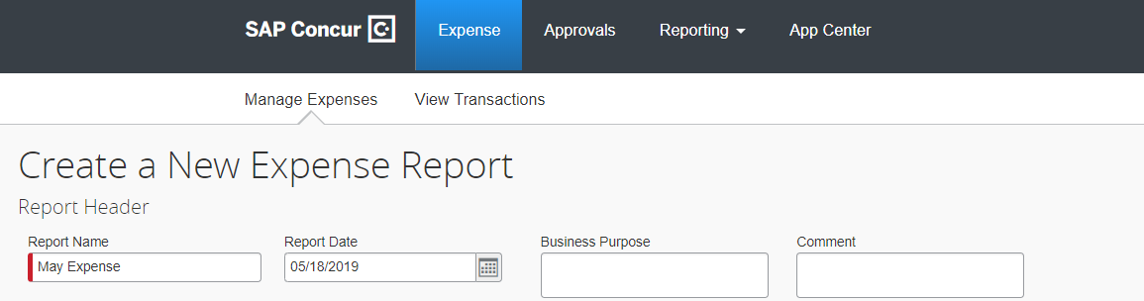

- Choose the type of expense (travel, mileage, meals etc.)
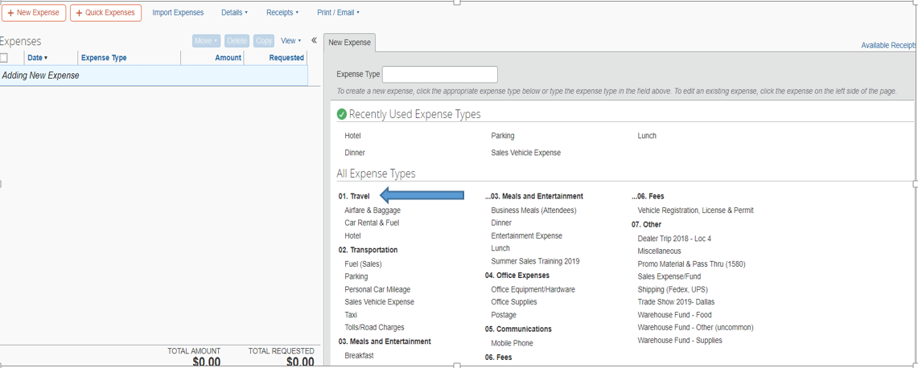

- Add detailed information and attach a receipt to each transaction.
- Expense Type
- Transaction Date
- Business Purpose
- Vendor
- Vendor Description
- Payment type
- Amount paid
- The warehouse location the expense is generated from.
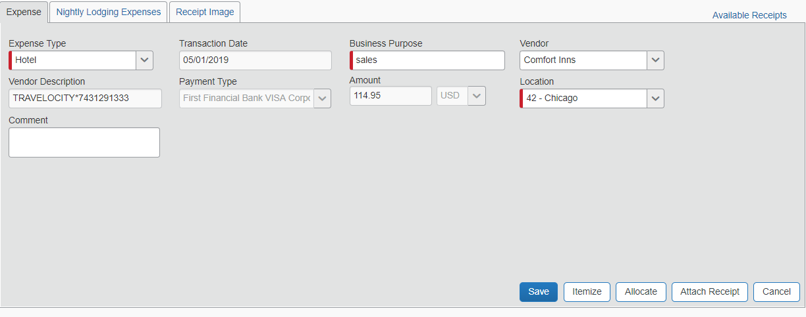

- Adding attendees to business meals.
- Select Business Meals (Attendees)
- Select New Attendee and add names and information of guest and click save.
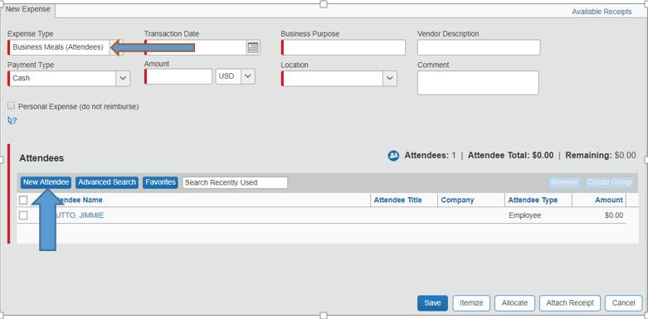

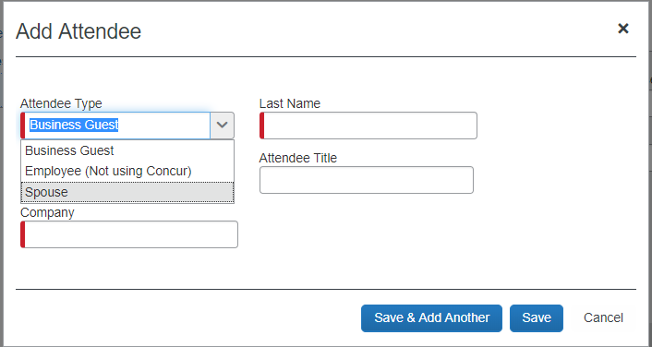

Submitting Your Expense Report (Must be done by the 15th of the month following the expense being accrued)

- On the expense report page, click submit report. The final review window appears.
- Review the information for accuracy. You can print, attach receipts, make changes or view.
- Click Accept & Submit

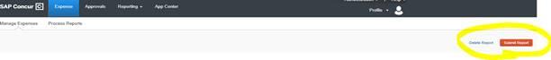
For training guides and demonstrations please go to https://www.concurtraining.com/standard/index

Video Library
All the following videos are located on K&M Tire’s very own Video Website. Click https://kmtire.vids.io/videos to be directed to the webpage. From this point, you will see multiple videos. Each video will require a password to view it. The password for the following videos is: KMTIRE1970!

Each of the titles below are videos you can find on the referenced website. They will aid in your understanding of what each document/system/report is used for, as well as how to successfully utilize each.

How to Videos
MaddenCo
Dashboard
Price Level Request
Program Request
Spot Opportunities
Credit Application
Dealer Request Form
Common Ownership Form
Release of Liability
Intranet
Customer Information
Sales Analysis
Ranking Report
Inventory Control
Open Closed Order
Weblink Login

Online Vendor Training
Many manufacturers have spent time and money to give us a useful resource to self-educate. It is our responsibility to stay in touch with new products and programs for the brands that we carry. Gaining this knowledge will help you stand out from the competition. Your customers will have more confidence in you knowing that you understand the products you are selling them. Most of the modules will take 10 minutes or less to complete and are highly informative.
Brand | Acct# | ZIP | W E B S I T E L I N K S
Bridgestone / Firestone / Fuzion | 665339 |  | http://www.mybridgestoneeducation.com
BSFS Continued - Adding PLT, AG or Commercial Training --> | Once you have an acct, login and go to the upper right corner and click the drop down next to your name. Select "Company Info -> Add New Business Unit -> Select Commercial -> Click Next -> Complete your details and select AG and all Commercial Tires you sell -> Click Next -> Enter 665339 and click the green button"
Continental / General - Engage 360 | 8210455 |  | contilink.com (click on ENGAGE360 Training)
Goodyear Learning Center | 184481 |  | thegoodyearlearningcenter.com (you will need to sign up for gyrewardsplus.com first)
Yokohama Exceed | 10000837 | 45833 | http://exceed.yokohamatire.com
Cooper Tire & Mastercraft | 229303 |  | http://ecooperuniversity.xceleratemedia.com
Pirelli Training | 7006954 |  | https://tyrecampus.pirelli.com/home.php
Mickey Thompson | 229303 |  | http://www.mickeythompsontires.com/training
Falken Peak | 20171 |  | http://www.falkenpeaktraining.com
Nexen Ace | 202 |  | https://www.nexenace.com
Carlisle | 66289 |  | https://training.carlstargroup.com

Appendix A: Referenced Documents
Table 1 - Referenced Documents
Document Name | Document Location and/or URL | Audit Schedule | Last Reviewed
Blank W-9 | F:\Credit & Collections\Public\Tax Forms\Blank W-9.pdf | Government  Provided | n/a
K&M Account Application | F:\Credit & Collections\Public\Credit\Account Application - K&M Tire.pdf | Annually | 10/31/2018
Release of Liability | F:\Credit & Collections\Public\Credit\ReleaseOfLiability.pdf | Annually | 12/5/2017
Common Ownership Form | :\Credit & Collection F s\Public\Credit\CommonOwnershipForm | Annually | 10/31/2018
Price Level Change Request Form | F:\Sales\Public\Sales SOP\Price Level Change Request Form.xlsx
Dealer Request Application | F:\Credit & Collections\Public\Credit\Dealer Request Fillable.pdf | Annually | 9/21/2018
Appendix B: Revision History Tracking
The following table records information regarding changes made to the SOP Binder.
Table 2 - Revision History Tracking
Section Number | Date | Author/Owner | Description of Change
Appendix A | 2/19/2020 | Cassie Johnson | Added Reference Documents + links
3. | 3/17/2020 | Tom Schadl | Added new section 3. “Welcome”
7. | 3/17/2020 | Tom Schadl | Added detail to “Outside Sales Best Practices”
8. | 3/17/2020 | Tom Schadl | Added detail to “Telenotes - CRM”
9. | 3/17/2020 | Tom Schadl | Added detail to “Weblink Best Practices”
12. | 3/17/2020 | Tom Schadl | Added detail to “Sales Calls Best Practices”
14. | 3/17/2020 | Tom Schadl | Added new section 14. “Conclusion”
5. | 3/17/2020 | Cassie Johnson | Added snip of org charge & brief description
6. | 3/17/2020 | Cassie Johnson | Fixed links to each Job Description
11.1 | 3/17/2020 | Cassie Johnson | Added “Dashboard Outline” sheet and link
11.2 | 3/17/2020 | Cassie Johnson | Added brief description of what MaddenCo is and how to log in.
Entire SOP | 3/17/2020 | Cassie Johnson | Updated all videos to be linked to the K&M TV website instead of YouTube
Entire SOP | 7/29/2020 | Joni Zerkel | Looked over SOP for broken links updated links that were no longer working or updated.
Entire Sop | 3/31/2021 | Tom Schadl | Updated Weblink screen shots to current version. Fix all hyperlinks that were not working.
Entire SOP | 4/6/2023 | Tom Schadl, Travis Siemering, Jay Goring | Updated complete SOP
 | 7/14/23 | Kayla Perrine | Updated SOP
 | 7/18/23 | Kayla Perrine | Updated SOP

